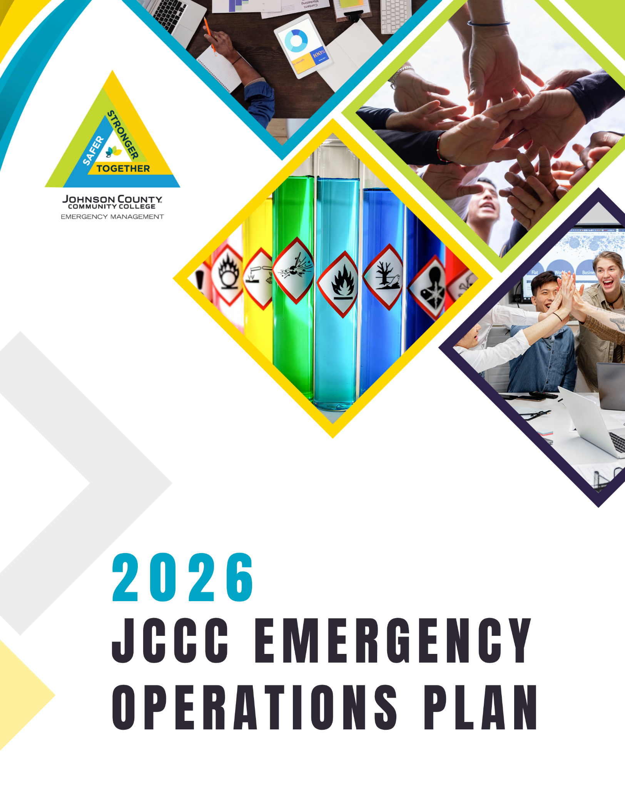

Table of Contents
Letter of Promulgation 5
Record of Distribution 6
Record of Changes 7
SECTION 1: INTRODUCTION 10
Vision…………………………………………. 10
Mission……………………………………………….. 10
Emergency planning program benefits 10
Guiding Principles 10
What is Preparedness? 11
Integrated Emergency Management 12
Mission Areas and Core Capabilities 13
Core Capabilities 13
JCCC’s Emergency Operations Plan 14
JCCC Mission Continuity Plan – (Not included in this Plan) 17
JCCC Disaster Recovery Plan – (Not included in this Plan) 17
Enterprise Risk Assessment 17
Definition of an Incident 17
Definition of an Emergency 18
Definition of a Disaster 18
Levels of an Emergency 18
Laws and Authorities 20
Coordination with Local, County and State Agencies 23
Planning Assumptions 23
Activation of the Plan/College State of Emergency 24
Plan Distribution 24
Plan Maintenance and Review 25
SECTION 2: Establishment and Activation of the Emergency Operations Plan (EOP) and the Emergency Operations Center (EOC) RESERVED
Establishment and Activation of the EOP and the EOC/VEOC (Virtual Emergency Operations Center) ” “ ”
President Succession of Authority “ “ “
Incident Response Team (IRT) “ “ “
Incident Activation Protocol “ “ “
Response Priorities “ “ “
Executive Policy Group (EPG) “ “ “
Duties and Responsibilities of the EPG “ “ “
Incident Command System (ICS) “ “ “
Incident Command “ “ “
Crisis Management Team (CMT) “ “ “
Emergency Operations Center (EOC) “ “ “
Setting up and operating the Emergency Operations Center “ “ “
EOC Locations…………………………………………………………………………….. “ “ “
EOC Activation………………………. “ “ “
EOC Activation Levels “ “ “
EOC Operations Cycle “ “ “
Deactivation………………………………. “ “ “
SECTION 3: EOC Checklists of Responsibilities RESERVED
CHECKLIST 1: Emergency Operations Center (EOC) Director/Deputy EOC Director “
CHECKLIST 2: Liaison “ “ “
CHECKLIST 3: Emergency Operations Center Support Staff “ “ “
CHECKLIST 4: Public Information Officer/Communications Support Team “ “ “
CHECKLIST 5: Operations Coordinator “ “ “
CHECKLIST 6: Public Safety/Law Enforcement “ “ “
CHECKLIST 7: Campus Services/Facilities “ “ “
CHECKLIST 8: Information Services “ “ “
CHECKLIST 9: Human Resources “ “ “
CHECKLIST 10: Student Success & Learner Engagement “ “ “
CHECKLIST 11: Instruction/Academics & WDCE “ “ “
CHECKLIST 12: Planning Coordinator “ “ “
CHECKLIST 13: Situation Unit and Documentation “ “ “
CHECKLIST 14: Space Management “ “ “
CHECKLIST 15: Logistics Coordinator “ “ “
CHECKLIST 16: Procurement “ “ “
CHECKLIST 17: Volunteer Management “ “ “
CHECKLIST 18: Emergency Food, Water and Sanitation “ “ “
CHECKLIST 19: Transportation “ “ “
CHECKLIST 20: Finance Administration Coordinator “ “ “
CHECKLIST 21: Emergency Accounting “ “ “
CHECKLIST 22: Insurance “ “ “
SECTION 4: Annexes RESERVED
ANNEX – A: Crisis Communications, Emergency Alerts and Warnings “ “ “
ANNEX – B: Public Information “ “ “
ANNEX – C: Resource Management “ “ “
ANNEX – D: Evacuation “ “ “
ANNEX – E: Campuswide Evacuation “ “ “
ANNEX – F: Lockdown “ “ “
ANNEX – G: Shelter-In-Place “ “ “
ANNEX – H: Mass Care / Sheltering “ “ “
ANNEX – I: Armed Intruder / Active Threat / Workplace Violence “ “ “
ANNEX – J: Fire Emergency “ “ “
ANNEX – K: Bomb Threat “ “ “
ANNEX – L: Civil Unrest On Campus “ “ “
ANNEX – M: Part 1: Community Health Crisis “ “ “
ANNEX – M: Part 2: Mass Prophylaxis Site Dispensing Plan in cooperation with Johnson County Department of Health and Environment “ “ “
ANNEX – N: Earthquake “ “ “
ANNEX – O: Hazardous Materials “ “ “
ANNEX – P: Tornado / Severe Weather / Shelter “ “ “
ANNEX – Q: BIT – Behavioral Intervention Team “ “ “
ANNEX – R: Transportation Accident “ “ “
ANNEX – S: Medical/Mass Casualty “ “ “
ANNEX – T: Death of Student or Employee “ “ “
SECTION 5: Appendices RESERVED
APPENDIX - A: Emergency Operations Center Primary and Alternate Recommended Staff Assignments “ “ “
APPENDIX - B: Emergency Contact List “ “ “
APPENDIX - C: Emergency Operations Center (EOC) Maps and Facility Information “
APPENDIX - D: Emergency Operations Center Forms “ “ “
APPENDIX - E: Resources and Contact Information “ “ “
APPENDIX - F: Training, Drills and Exercises (not all inclusive) “ “ “
APPENDIX - G: Glossary of Acronyms “ “ “
Table of Figures……………………... 26

Letter of Promulgation
Johnson County Community College (JCCC) is committed to protecting the welfare of its community members as well as its intellectual property and facilities. For this reason, JCCC has developed the Emergency Operations Plan. With this plan, the College strives to minimize the impact of emergencies and maximize the effectiveness of the campus community’s response to and recovery from their inevitable occurrence.
We can best prepare to meet the enormous challenges that emergencies present by working together. As such, the Emergency Operations Plan includes a chain of command that establishes the authority and responsibilities of campus officials and staff members. The plan also requires departments to designate emergency leaders who will have the authority to make modifications in emergency procedures and commit resources to emergency management efforts, as necessary.
The plan is written with explicit interest in the welfare and safety of the students, faculty, staff, and visitors. In accordance with the National Response Framework, all JCCC departments that have responsibilities/functions delineated in this plan will use the National Incident Management System (NIMS). NIMS allows and ensures proper coordination between local, state, and federal organizations in emergency response. Furthermore, the Incident Command System (ICS) will be utilized in all on-scene management of emergency events.
Pursuant to the authority of the Board of Trustees, this Emergency Operations Plan, its attachments, appendices, and annexes are adopted as Policy upon declaration of an emergency. Each administrator, department chair, director, and functional supervisor is directed to take necessary actions to implement it by developing written internal procedures that detail support required by the plan and then maintain preparedness to quickly put the plan into action.
This plan, when used properly and updated regularly, will assist JCCC personnel in accomplishing their primary responsibilities: life safety, incident stabilization, and property preservation. This plan and its provisions will become official when it has been signed and dated below by the concurring JCCC officials and hereby gives authority and responsibility to JCCC officials to perform their duties, as indicated in this plan, before, during and after an incident.
The JCCC Emergency Management Director is designated as the responsible official to coordinate, implement, and supervise emergency operations on behalf of the President and other administrative officers. They are empowered to coordinate with other local, state, and federal emergency operations agencies in the event of emergencies that may require implementation of this plan.

May 15, 2026
_______________________________________ _______________________________________
Date President

Record of Distribution
Name | Title | Agency | Method of Distribution (Electronic or Hard Copy) | # Of  Copies | Date of Delivery
http://list.jccc.edu | webserver |  | Electronic |  | 4/4/15
https://isg.jccc.edu | webserver |  | Electronic |  | 6/1/18
https://isg.jccc.edu | webserver |  | Electronic |  | 6/15/19
Shared Site | Teams/SharePoint | JCCC | Shared S https://jcccedu.sharepoint.com/:w:/r/sites/IncidentResponse/site |  | 11/19/21
All EPG & IRT Members | EOP | JCCC | Hard Copy |  | 6/15/19
EOC Locations | EOP | JCCC | Hard Copies | 5 each at 4 EOC’s = 20 copies | 2/22
EOC Location | EOP Final 2023 | JCCC | Hard Copies | 5 each at 4 EOC’s = 20 copies | 12/23
IRT SharePoint Site/CMT SharePoint Site in TEAMS | EOP Final 2023 | JCCC | Electronic |  | 12/2023
EOP – 2023 Version | Bold Planning Solutions | JCCC | Electronic |  | 12/2023
All EPG & IRT Members | EOP | JCCC | Hard Copy |  | 2/2024
All EPG & IRT Members  and upon CMT request | EOP | JCCC | Hard Copy |  | 4/2025
All EPG & IRT Members and upon CMT requests | EOP | JCCC | Hard Copy |  | 4/2026
All CMT Members | EOP | JCCC | Electronic in TEAMS CMT site |  | 4/2026

Record of Changes
CHANGE # | PAGE NUMBER(s) | DATE OF CHANGE | CHANGE MADE BY | SUMMARY OF CHANGES
1 | (1) | 5/1/18 | EM | Letter of Promulgation
2 | 8 | 5/1/18 | EM | EM Phased Approach
3 | Throughout | 5/1/18 | EM | Every 2 years for update
4 | Annex ( ) | 5/1/18 | EM | Infectious to communicable
5 | Annex ( ) | 5/1/18 | EM | Disability to Functional needs
6 | Throughout | 5/1/18 | EM | Positions and Contacts updated
7 | 11 | 5/1/18 | EM | Risk Assessment 2017/18
8 | 16 | 5/1/18 | EM | Current KS Weapons Statute
9 | Annex N | 5/1/18 | EM | Added Dispensing Site Plan
10 | All Annexes | 11/2016-5/2017 | EM | All Annexes reviewed and minor updates per Planning team
11 | Appendix I | 2/2017 | EM | NEW BIT Plan
12 | Appendix D | 1/2017 | EM | Added ICS Fill-in Chart - Forms
13 | (1) | 6/1/19 | EMD | Letter of Promulgation
14 | (9) | 6/1/19 | EMD | National Prep Goal
15 | (9) | 6/1/19 | EMD | Core Capabilities
16 | (33) | 6/1/19 | EMD | Deactivation of EOC
17 | Annex | 6/1/19 |  | BIT Updated Plan
18 | Annex N | 6/1/19 |  | Updated Site Dispensing Plan
19 | Annex E | 6/1/19 | EMD | Campuswide Evacuation
Major Rewrite | Throughout plus 3 new Annexes | 12/2023 | EMD | Major rewrite of entire Plan, New Annexes, and reorganization of EPG, IRT, Incident Notification Protocol, EOC Function role adjustments- See saved redlined copy dated 12/2023 for all documented changes. - See Update Summary Presentation presented to Cabinet on 12/12/23.
20 | All | 4/2025 | EMD | Minor Changes only throughout. Some corrections in phone numbers, names, points of contact, minor wording, executive in charge order to match operations.
21 | All | 4/2026 | EMD | Entire plan reformatted to be maintained by Emergency Mgmt. Department.
22 | 6 | 4/2026 | EMD | Letter of Promulgation – updated President signoff
23 | 8-9 | 4/2026 | EMC | Record of Changes updated
24 | Section 1 | 4/2026 | EMD | Laws and Authorities updated by Legal.
25 | Section 2 – Checklist 15 | 4/2026 | EMD | Updated Logistics Coordinator language
26 | Section 4 – Annex Reviews | 4/2026 | EMD | Annexes updated: Lockdown, Armed Intruder/ Active Threat/Workplace Violence, Bomb Threat, Civil Unrest on Campus, Hazardous Materials, Medical-Mass Casualty, Behavior Intervention Team
27 | Section 5 - Appendices | 4/2026 | EMD | Appendices updated: EOC Assignments, CMT Contact List, EOC Locations, Forms, Resources, Training Drill & Exercises
28 | All | 4/2026 | EMD | Reference for Continuing Ed has been updated to WDCE where possible

SECTION 1:

  - Introduction

  - Emergency Operations Plan
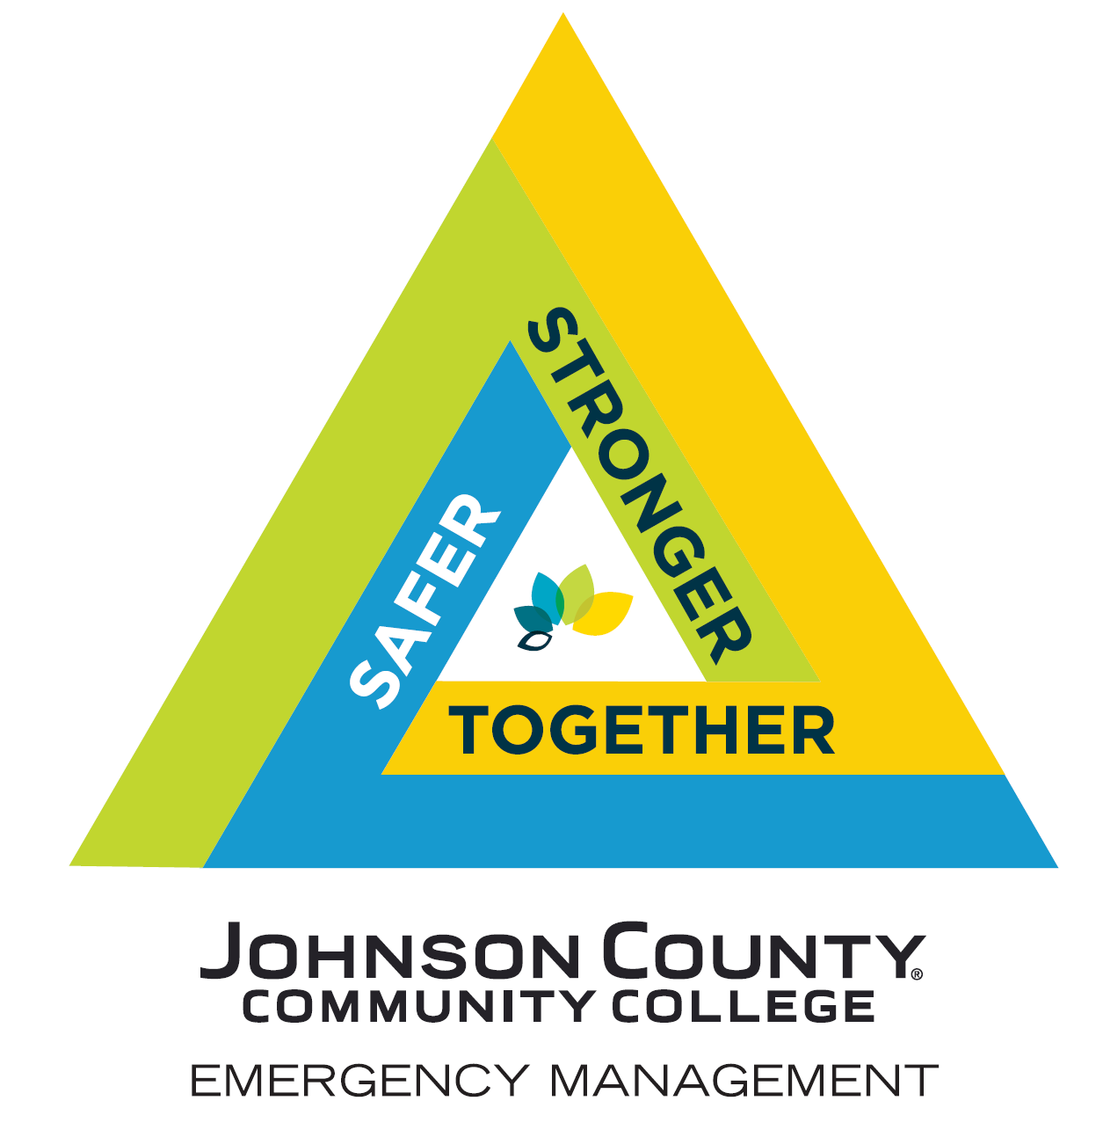

SECTION 1: INTRODUCTION
Emergency Management at JCCC

Vision
Johnson County Community College strives to establish and maintain a disaster-resilient College in which the safety and security of students, faculty, staff, and visitors is paramount.

Mission
The Office of Emergency Management and named Crisis Management Team Members mitigates, prepares for, responds to, and recovers from incidents and emergencies that affect the campus community. Functions of the Department and associated teams include:
- Identifies and assesses potential hazards and vulnerabilities that could affect the College.
- Prepares, keeps current, and distributes campus emergency response plans.
- Coordinates resources before, during and after an incident or emergency.
- Provides College leadership, guidance, and support during an incident or emergency.
- Coordinates and communicates with College constituents and local, state, and federal agencies in emergency planning and response.

Emergency planning program benefits
- Protection of life, property, the environment, essential services, and critical facilities
- Reduced vulnerability and exposure to future crisis and disaster events
- Diminished post-crisis economic hardship for the campus and community
- Reduced short-term and long-term recovery and reconstruction costs
- Quicker resumption of College functions, including education (academic continuity), business systems, and services
- Increased cooperation and communication within the community through the planning process, exercises, and training
- Support for the College mission and strategic plan

Guiding Principles
Support JCCC’s mission of changing lives through learning, embracing student success, supporting the College’s innovative spirit, community leadership, and continuous improvement by aligning emergency management planning efforts with the mission by continuously refining the following approaches:
- Collaboration – create and sustain a governance model that advocates and supports an inclusive team atmosphere, builds consensus, and facilitates communication.
- Comprehensiveness – achieve an all-hazards planning methodology that takes into consideration all phases, all stakeholders, and all impacts relevant to incidents and crisis events.
- Coordination – synchronize emergency activities to accomplish a common purpose and common goals.
- Integration – establish unity of effort among all levels of administration and segments of the campus and local community.
- Prevention – anticipate future threats and take preventive and preparatory measures to build a disaster-resilient college.
- Risk-driven Improvement – apply sound risk management principles in assigning priorities and resources.

What is Preparedness?

National Preparedness Goal
Preparedness, essentially, is having a secure and resilient community, one that has the capabilities to withstand the threats and hazards that pose the greatest risk.
The Federal Emergency Management Agency (FEMA) National Preparedness Goal defines what it means for the whole community to be prepared for all types of disasters and emergencies. The goal is succinct: (FEMA)
“A secure and resilient Nation with the capabilities required across the whole community to prevent, protect against, mitigate, respond to, and recover from the threats and hazards that pose the greatest risk.”
These risks may include natural disasters, disease pandemics, chemical spills and other manmade hazards, terrorist attacks, and cyber-attacks.
This same definition applies to communities and jurisdictions at any level (local, state, tribal, etc.).
Notice that there is an underlying premise in this description of preparedness: if you have the capabilities to manage the greatest, worst-case probable situation, you will also be prepared to handle lesser incidents - the routine and less-than-catastrophic incidents that make up most of emergency management.
The key is building and sustaining capabilities at all levels.

Integrated Emergency Management
Integrated emergency management is a key concept adopted by emergency managers. It embodies an all-threats/hazards approach to the direction, control, and coordination of disasters regardless of their location, size, or complexity, and it goes hand-in-hand with the concept of whole community preparedness. Integrated emergency management is more than a methodology; it is a culture to achieve unity of effort—a way of thinking about emergency management as a joint enterprise. It is intended to create an organizational culture that is critical to achieving unity of effort between government, members of the community, nongovernmental organizations, and the private sector. Emergency management must be integrated into daily decisions, not just during times of disasters.
Emergency Management includes the coordination of all aspects of the four phases of emergency management – mitigation, preparedness, response, and recovery.
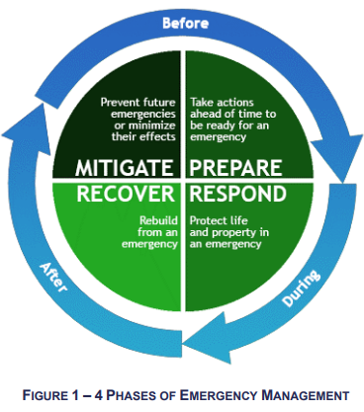
Figure 1 Four Phases of Emergency Management
Johnson County, KS Emergency Operations Plan 2024

Mission Areas and Core Capabilities
Mission Areas are comprised of the capabilities required for achieving the function at any time (before, during, or after an incident) and across all threats and hazards.

The five mission areas include:
  - Prevention: The capabilities necessary to avoid, prevent, or stop a threatened or actual act of terrorism. The term “prevention” refers to preventing imminent threats.
  - Protection: The capabilities necessary to secure the homeland against acts of terrorism and human-caused or natural disasters.
  - Mitigation: The capabilities necessary to reduce loss of life and property by lessening the impact of disasters.
  - Response: The capabilities necessary to save lives, protect property and the environment, and meet basic human needs after an incident has occurred.
  - Recovery: The capabilities necessary to assist communities affected by an incident to recover effectively.

Core Capabilities
There are 32 core capabilities identified in the National Preparedness Goal (https://www.fema.gov/national-preparedness-goal) and is intended to assist everyone who has a role in achieving all of the elements in the Goal.

The Core Capabilities by mission area:
  - Distinct critical elements necessary to meet the National Preparedness Goal.
  - Essential for the execution of each Mission Area.
  - Developed and sustained through the combined efforts of the whole community.
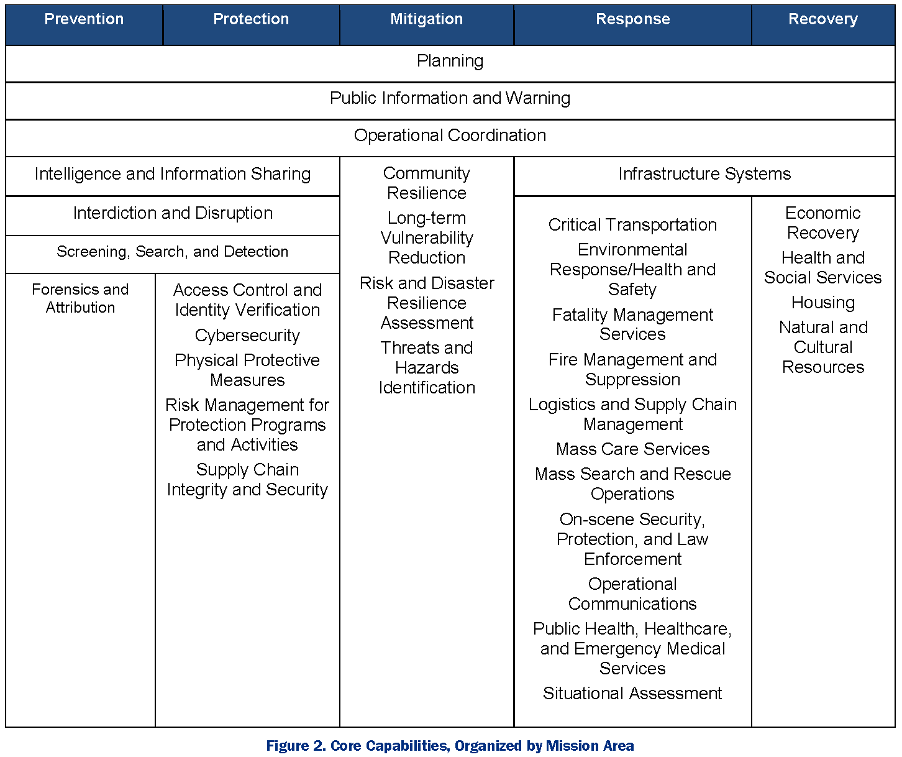
Figure 2 Core Capabilities, Organized by Mission Area
SOURCE: FEMA

JCCC’s Emergency Operations Plan
JCCC’s Emergency Operations Plan outlines policies and procedures for managing incidents that may threaten the health and safety of students, faculty, staff, and visitors at JCCC; harm College property or reputation; or disrupt College academics, programs, and services.
Emergencies can occur at any time without warning. A plan such as this one allows the College to respond more effectively and efficiently in a crisis, coordinate its response and enhance its recovery effort.
This plan applies to a broad range of potential emergencies, including but not limited to severe weather, fires, explosions, the release of hazardous materials, infectious disease, extended power outages, incidents of violence and other events that may affect the life and safety of persons or facilities or the reputation of JCCC.

Purpose of the Plan
The overall purpose of this plan is to present procedures and protocols for responding to emergency conditions at JCCC and managing the process of restoring College operations.
The plan addresses the immediate requirements for an incident, which may or may not rise to the level of an emergency declaration, and in which normal operations are interrupted, and special measures must be taken to:
- Save and protect the lives of students, faculty, staff, visitors, and the campus community.
- Manage communications and information regarding emergency operations and campus safety.
- Provide and analyze information to support decision-making and action plans.
- Provide essential services and operations.
- Manage College resources effectively in an emergency situation.
The plan outlines the management structure, key responsibilities, emergency assignments, and general procedures to follow during and immediately after an emergency or disaster. It supplements procedures currently in place for the day-to-day management and operation of JCCC.

Scope of the Plan
This plan outlines how JCCC, including faculty, staff, students, visitors, and the campus community will respond to an incident or emergency situation. The plan establishes the basic framework for critical incidents and emergency management.
The Emergency Operations Plan is stored electronically in Microsoft Teams Crisis Management Team SharePoint Site for redundancy and Cloud back-up. Hard copies of the plan are also maintained at each Emergency Operations Center (EOC). A public version of the plan is available on the College website.
Because this plan does not cover the needs of every area in the College, individual divisions and departments should create supplements to this plan to support their own needs. Each division is expected to develop and maintain its own internal response plan as well as employee contact lists in case of an emergency. It is also the responsibility of each division and department to ensure its plans are up to date. Copies of department and division plans should be shared with the Mission Continuity and Risk Management Department.
College activities operating in off-campus locations owned or managed by entities other than JCCC (such as West Park) must also coordinate their emergency response with the relevant property management organization.

Objectives of the Plan
The objectives of this plan are to:
- Organize incident and emergency response structures.
- Provide clear and easy-to-follow guidelines and checklists for the most critical functions.
- Create an easy-to-follow format so users can quickly determine their roles, responsibilities, and primary tasks.
- Link and coordinate processes, actions, and the exchange of critical information into an efficient and real-time operation.
- Unity of effort
Establish structures for communications and information management.
- Set up a central point of communication both for the receipt and transmission of urgent information and messages.
- Establish official channels of contact for the College during incidents and emergencies when normal channels are interrupted.
- Provide full-service communication for voice, data, and operational systems.
- Collect disaster information for notification, public information, documentation, and post-incident analysis.
- Provide a basis for training staff in emergency response practices and procedures.
Establish decision-making processes.
- Determine through a clear decision-making process the level of operation and extent of emergency control and coordination that should be activated when incidents and emergencies occur.
Provide structure for operations during incidents and in an emergency.
- Use College resources efficiently to implement a comprehensive and efficient response.
- Be prepared through the Emergency Operations Plan for the possibilities and eventualities of incidents rising to the level of emergencies.
Position the College for optimal recovery.
- Prepare to resume normal operations as soon as possible.
- Provide documentation and information support for JCCC response and to federal disaster assistance programs.

JCCC Mission Continuity Plan – (Not included in this Plan)
The JCCC Mission Continuity Plan outlines procedures and guidance how the College will maintain essential functions during unexpected events or disruptions. Key elements include scenario and process specific risk assessment, business impact analysis and recovery procedures developed to ensure the execution of essential functions via back up procedures, relocation or alternate resource plans as required to maintain continuous operation of essential functions. The Mission Continuity Plan is housed separately and is facilitated and maintained by the Mission Continuity & Risk Management Department.

JCCC Disaster Recovery Plan – (Not included in this Plan)
The JCCC Disaster Recovery Plan contains detailed instructions for restoring critical operations and data to minimize disruption and ensure College continuity. The plan integrates tactics to address data protection, backup, restoration, and operational resumption to limit the impact of various risks. The Disaster Recovery Plan is document is housed separately and facilitated by the Mission Continuity & Risk Management Department.

Enterprise Risk Assessment
Since 2012, JCCC has conducted an annual Risk Assessment which surveys the President’s Cabinet and the Crisis Management Team. The results of the survey are used as a guide to the analysis, prioritization, mitigation, and monitoring of various risk categories. Insights from the risk assessment process help prioritize program development, exercise, and training needs. The Risk Assessment process is a part of the Enterprise Risk Management Program and is coordinated by the Mission Continuity & Risk Management Department.

Definition of an Incident
An occurrence, natural or human-caused, that requires a response to protect life or property. Incidents can, for example, include major disasters, emergencies, terrorist attacks, terrorist threats, civil unrest, wildland and urban fires, floods, hazardous materials spills, nuclear accidents, aircraft accidents, earthquakes, hurricanes, tornadoes, tropical storms, tsunamis, war-related disasters, public health and medical emergencies, and other occurrences requiring an emergency response. (FEMA)

Definition of an Emergency
Any incident, whether natural, technological, or human-caused, that requires responsive action to protect life or property. Under the Robert T. Stafford Disaster Relief and Emergency Assistance Act, an emergency means any occasion or instance for which, in the determination of the President, Federal assistance is needed to supplement State and local efforts and capabilities to save lives and to protect property and public health and safety, or to lessen or avert the threat of a catastrophe in any part of the United States. (FEMA)
An emergency may result in a declaration of a state of emergency for the College. Declaration of emergency may be issued by the College President or designated Executive in Charge.

Definition of a Disaster
A disaster is an occurrence of a natural catastrophe, technological accident, or human caused event that has resulted in severe property damage, deaths, and/or multiple injuries. (FEMA)
A disaster may result in a declaration of a state of emergency for the College. Declaration of emergency may be issued by the College President or designated Executive in Charge.

Levels of an Emergency
JCCC categorizes emergencies into five response levels according to severity, potential impact, resource requirements, EOC activation level, and the level of assistance or support required from external emergency services.

JCCC Incident/Emergency Level Matrix
Levels of an Incident/Emergency | Description | Estimated Duration | Incident Activation | EOC Activation Level
Level 1: A high impact incident/disaster or imminent threat.  Examples: Major weather event, terrorism, active shooter, pandemic, earthquake, building collapse, mass casualty. | Entire campus and/or surrounding community  (Widespread damage) | > 48 Hrs. | Activate Incident Activation Protocol | Full EOC activation including IRT, EPG, and CMT. May require 24/7 shifts and staffing.
Level 2: A medium impact incident or potential threat.  Examples: Structure fire, long term power outage, substantial network or systems outage, multi-fatality incident, hazmat, severe storm, civil disorder, or an external emergency that may affect College resources. | Sizable portions of the campus community | 8-48 Hrs. | Activate Incident Activation Protocol | Partial or Full EOC activation including all IRT and certain CMT positions staffed.
Level 3: A low impact incident that is resolved with college resources or limited outside help.  Examples: Odor complaint, localized chemical spill, small fire, power disruption, network or systems failure, water damage. | Localized department or building incident | 4-8 Hrs. | Activate Incident Activation Protocol | IRT activation (virtual or physical). Likely no EOC activation.
Level 4: A low impact event that is quickly resolved with existing college resources.  Examples: minor technology issue, minor facility issue (e.g., water leak, minor/no damage). | Localized department or building event (no impact to classes, damages, change of operations, or movement of people) | <4 Hrs. | Activate Incident Activation Protocol as needed. Follow campus department internal protocol. EM is notified. | No IRT activation. No EOC activation. Campus departments respond and communicate as needed with impacted departments.
Level 5: Monitoring Certain Operations  Examples: Graduations, campus high profile events, weather monitoring event. | Monitoring of operations and certain campus events. | As needed | Activate Incident Activation Protocol As Needed | IRT/EOC may be activated with EM personnel virtually or physically for weather or event monitoring.
Virtual EOC Activation (VEOC): When a physical activation is not possible due to environmental or safety conditions, hazards, after hours or the EOC is inaccessible or damaged. Phone and web based tools (Zoom/Teams) will be used to Collaborate, Communicate and Coordinate.
Note: This chart does not represent all possible scenarios, nor does it mandate specific EOC activation levels. This matrix is to serve as a guide.
** Activate Incident Activation Protocol for every incident report!

Levels 1-3 will be debriefed at the conclusion for the purpose of review, training, and future enhancement of this Plan.

Laws and Authorities
Emergency Preparedness Regulations & Standards
Category | Name | Common Name | Authority | Description
FEDERAL  Department of Homeland  Security/ FEMA | Robert T. Stafford Disaster Relief and Emergency Act, 42, USC § 5121 et seq |  | Robert T. Stafford Disaster Relief and Emergency Act, 42 U.S.C. § 5121 et seq | It is the intent of the Congress, by this Act, to provide an orderly and continuing means of assistance by the Federal Government to State and local governments in carrying out their responsibilities to alleviate the suffering and damage which result from such disasters.
FEDERAL  Department of Homeland  Security/ FEMA | Federal Emergency Management Agency (FEMA) |  | Title 44 CFR, Federal Emergency Management Agency, Department of Homeland Security | FEMA’s mission is to support our citizens and first responders to ensure that as a nation we work together to build, sustain, and improve our capability to prepare for, protect against, respond to, recover from, and mitigate all hazards. Congress' intention was to encourage states and localities to develop comprehensive disaster preparedness plans, prepare for better intergovernmental coordination in the face of a disaster, encourage the use of insurance coverage, and provide federal assistance programs for losses due to a disaster.
FEDERAL  Department of Homeland  Security/ FEMA | National Incident Management System |  | National Incident Management System (October 2017) | The National Incident Management System (NIMS) provides a systematic, proactive approach to guide departments and agencies at all levels of government, nongovernmental organizations, and the private sector to work seamlessly to prevent, protect against, respond to, recover from, and mitigate the effects of incidents, regardless of cause, size, location, or complexity, in order to reduce the loss of life and property and harm to the environment. NIMS works hand in hand with the National Response Framework (NRF). NIMS provides the template for the management of incidents, while the NRF provides the structure and mechanisms for national-level policy for incident management.
FEDERAL  Department of Homeland  Security/ FEMA | National Response Framework |  | National Response Framework (October 2019) | This National Response Framework (NRF) is a guide to how the Nation conducts all-hazards response. It is built upon scalable, flexible, and adaptable coordinating structures to align key roles and responsibilities across the Nation, linking all levels of government, nongovernmental organizations, and the private sector. It is intended to capture specific authorities and best practices for managing incidents that range from the serious but purely local, to large-scale terrorist attacks or catastrophic natural disasters.
FEDERAL Environmental Protection Agency | Emergency Planning and Community Right-to-Know Act, 42 USC Chapter 116 |  | 40 C.F.R. § 370 | Requires the establishment of state/tribe emergency response commissions (SERCs/TERCs), which are responsible for coordinating certain emergency response activities and for appointing local emergency planning committees (LEPCs). Requires facilities to notify the SERC and LEPC of the presence and/or release of any extremely hazardous substance. All information submitted pursuant to EPCRA regulations is publicly accessible, unless protected by a trade secret claim.
FEDERAL  Department of Justice | Americans with Disabilities Act 42 U.S.C. §§ 12101-12213 | ADA | 28 C.F.R. § 36 | Although the Americans with Disabilities Act (ADA) does not require employers to have emergency evacuation plans, if organizations covered by the ADA opt to have such plans, they are required to include people with disabilities
FEDERAL  Department of Education | Title IX of the Education Amendment of 1972, 20 USC §§ 1681-1688 | Title IX | 28 C.F.R. §§ 42.201-42.215  34 C.F.R. § 106  45 C.F.R. §§ 86.1-86.9 | Prohibits discrimination on the basis of sex in education programs or activities receiving federal financial assistance including employment. Any grievance records relating to a Title IX violation or complaint must be retained for 7 years.
FEDERAL  Department of Education | Clery Act, 20 USC § 1092(f); Campus SaVE Act | Clery Act | 34 C.F.R. § 668.41 | As an institution receiving federal financial aid, JCCC must keep information about crime on and near its respective campuses and provide an annual report (including crime statistics, security measures, and policies, and where crimes should be reported) to all students, employees, and the Department of Education. Must report compliance with the Campus SaVE Act in Annual Security Reports beginning October 1, 2014.
FEDERAL  Department of Education | Clery Act, 20 USC § 1092(f); Campus SaVE Act | Clery Act | 34 C.F.R. § 668.46
FEDERAL  Department of Education | Campus Sex Crimes Prevention Act (§ 1601 of the Victims of Trafficking and Violence Protection Act of 2000) Public Law No. 106-386 |  | Public Law 106-386 | The Campus Sex Crimes Prevention Act requires sex offenders who are required to register under state law to provide notice of enrollment or employment at any institution of higher education (IHE) in that state where the offender resides, as well as notice of each change of enrollment or employment status at the IHE. In turn, this information will be made available by the state authorities to the local law enforcement agency that has jurisdiction where the IHE is located.
FEDERAL  Department of Education | 20 U.S.C. § 1232g | FERPA | 34 C.F.R. § 99 | FERPA protects the privacy of student education records, and generally requires the student’s written consent to release the records, unless an exception applies. FERPA’s health or safety emergency exception permits disclosures of personally identifiable information (PII) when the disclosure is necessary to protect the health or safety of the student or other individuals. See 34 C.F.R. §§ 99.31 (a)(10) and 99.36 Other exceptions include release to school officials, authorized government personnel, in connection with financial aid, in an emergency or for other specifically allowed purposes. The University must provide students with the right to inspect their education records and obtain written consent to release the records to anyone other than school officials, authorized government personnel, in connection with financial aid, in an emergency, or for other specifically allowed purposes.
KANSAS | Public Law No. 110-315 |  | KSA 48-945 | Declaration of state of emergency; exemption of drivers of utility service vehicles from certain requirements. (a) Upon application by any utility, the division of emergency management may declare a state of emergency in all or any part of the state whenever conditions exist which constitute an emergency, as defined in 49 CFR 390.5, as in effect on the effective date of this act or such later version as adopted by rules and regulations of the state corporation commission pursuant to K.S.A. 66-1,129, and amendments thereto
KANSAS | KSA 48-905a - Establishes Division of Emergency Management in Adjutant General's office |  | KSA 48-905a | Division of emergency management, establishment. (a) The division of emergency preparedness within the office of the adjutant general is hereby abolished and there is hereby established within the office of the adjutant general a division of emergency management. To the extent provided in this act, all of the powers, duties, and functions of such division of emergency preparedness are hereby transferred to and conferred and imposed upon the division of emergency management. The division of emergency management and the powers, duties and functions thereof shall be administered, by the adjutant general, who shall be the chief administrative officer thereof, under the supervision of the governor.
KANSAS | KSA 48-907 - Duties of Adjutant General for emergency preparedness |  | KSA 48-907 | Powers and duties of adjutant general. For the purposes of administering the division of emergency management and the powers, duties, and functions thereof.
KANSAS | KSA 48-924 - Governor's responsibility in disasters |  | KSA 48-924 | Disasters; responsibilities of governor; state of disaster emergency.
KANSAS | KSA 48-926 - Division of Emergency Management shall prepare and maintain a state disaster emergency plan |  | KSA 48-926 | State disaster emergency plan; rules and regulations.
KANSAS | KSA 48-928 - Duties of Division of Emergency Management |  | KSA 48-928 | Duties of division of emergency management
KANSAS | KSA 75-7c01 et seq, Kansas Personal and Family Protection Act |  | Kansas Personal and Family Protection Act, KSA 75-7c01 et seq
JOHNSON COUNTY COMMUNITY COLLEGE  Safety and Security Policies | Safety and Security Policy 610.00 |  | Safety and Security Policy 610.00 | 1) support a safe and secure environment in all buildings and grounds owned, leased, and operated by JCCC; 2) promote safety, emergency preparedness and business continuity through policy development and programing; 3) provide appropriate types and levels of security at College events and activities and 4) safeguard the College’s property and assets.
 | Infectious Disease Policy 611.00 |  | Infectious Disease Policy 611.00 | The purpose of this Policy is to prevent the spread or outbreak of communicable or infectious diseases, and it will be interpreted and administered in order to protect the health and well-being of the campus community.
 | National Incident Management System Policy 620.00 |  | National Incident Management System Policy 620.00 | Emergency Preparedness ensures the NIMS approach is incorporated into the College’s emergency management practices to help the College community prepare for, respond to, recover from, and reduce the effects of incidents and potential incidents, whether they are intentional, accidental, or natural.
 | Animals on Campus Policy 630.00 |  | Animals on Campus Policy 630.00 | Johnson County Community College endeavors to provide a safe and healthy learning environment. The uncontrolled or unsupervised presence of animals on campus compromises this environment.
 | Sexual Harassment Policy 650.00 |  | Sexual Harassment Policy 650.00 | Sexual Harassment means conduct on the basis of sex that satisfies one or more of the following: (1) an employee conditioning the provision of an aid, benefit, or service of the College on an individual’s participation in unwelcome sexual conduct (i.e., quid pro quo); or (2) unwelcome conduct determined by a reasonable person to be so severe, pervasive, and objectively offensive that it effectively denies a person equal access to the College’s education program or activity; or (3) Sexual Assault (as defined in the Clery Act), Dating Violence, Domestic Violence, or Stalking (as defined in the Violence Against Women Act (VAWA)).
 | Weapons Policy 660.00 |  | Weapons Policy 660.00 | The purpose of this Policy is to promote a safe and secure community college and learning environment. JCCC prohibits the possession or use of Weapons on Campus and at Off-Campus Activities, other than as set forth in the Policy.
 | Visitors on Campus Policy 614.00 |  | Visitors on Campus Policy 614.00 | The purpose of this Policy is to promote safe and orderly operation of the College and learning environment by establishing parameters for the presence and conduct of visitors on campus.
 | Protection of Minors on Campus Policy 613.00 |  | Protection of Minors on Campus Policy 613.00 | The purpose of this Policy is to promote the safety and welfare of Minors participating in Covered Activities sponsored by the College or by Third Parties on College property by establishing standards, obligations and expectations for the adults who work with Minors in Covered Activities.

Coordination with Local, County and State Agencies
JCCC will coordinate with local, county, and state agencies as appropriate under the circumstances of an emergency. Emergency coordination is shown below:
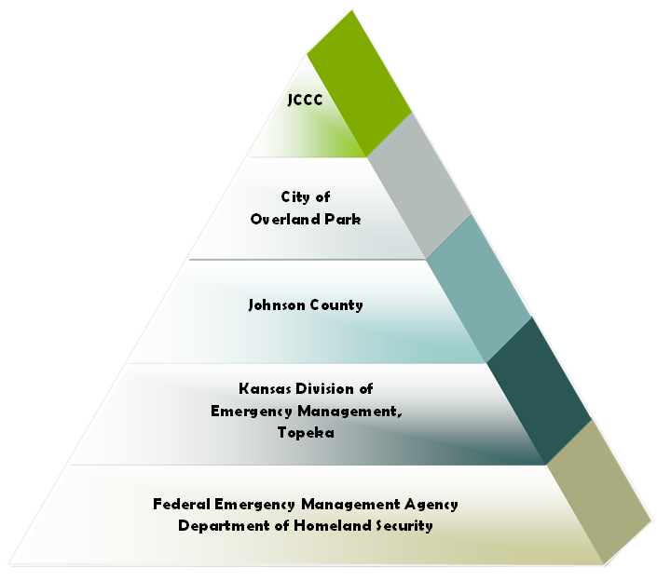
Figure 3 Emergency coordination pyramid with local, county, and state agencies.

Planning Assumptions
JCCC’s Emergency Operations Plan (and supplemental division plans) considers what the college would do in worst-case conditions like these:
- People may be injured or killed.
- Emergency support services such as police and fire are unable to respond promptly or at all.
- Critical utilities such as water, electricity, phone or information systems may be interrupted.
- Buildings and structures may be damaged.
- College personnel may be unable to get to or from their homes.
- Contact with family and friends may be interrupted.
- Suppliers may not be able to deliver materials.

The succession of events in an emergency is not predictable. Therefore, this plan serves only as a guide and may require modifications to meet the requirements of a specific emergency. The plan does not limit the use of good judgment and common sense in matters not foreseen or covered by its elements.

Activation of the Plan/College State of Emergency
A declaration of a state of emergency is necessary for the Plan to be fully activated and become Policy.
The authority to declare a campus state of emergency is granted to the College President or the designated Executive in Charge.
If a state of emergency is declared, it may become necessary to restrict access to specific areas on campus to authorized individuals. Only those authorized individuals who have been assigned emergency or resource duties will be allowed to enter the impacted area(s) or building(s).
When activated, the Emergency Operations Plan supplements the College’s administrative policies and procedures and serves as an emergency manual describing how to direct operations and staff assignments, procure and allocate resources, and restore normal services and operations. Division/department heads establish appropriate procedures within their work units to facilitate the implementation of the emergency plan.
During an emergency, users should follow and complete the tasks on the checklists contained in Section 3 of this plan, following the procedures and processes they have set in place for dealing with emergency situations. The lists will then be retained on file as official records of the emergency situation.

Plan Distribution
All members of the Executive Policy Group, Incident Response Team and the Crisis Management Team receive copies of the Emergency Operations Plan (hard copy and/or electronic). A public version of the EOP is available on the College website.
Copies of the Plan, including all appendices and annexes, are also kept in the JCCC Police Department, the Emergency Operations Centers and at off-site locations for use during training or in an actual emergency as well as electronically in the secure CMT SharePoint/Teams site.

Plan Maintenance and Review
JCCC’s Emergency Operations Plan was first drafted in 2013/2014 and regular updates in 2015, 2019, 2024, 2025, and 2026.
The Emergency Operations Plan will be reviewed, and updated regularly. Operational Annexes will be reviewed by functional departments regularly or as major re-writes are necessary.
Interim revisions may be made when one of the following occurs:
- A change in College site or facility configuration that materially alters the information contained in the plan or materially affects implementation of the Emergency Operations Plan.
- A material change in response resources.
- An incident or emergency occurs that requires plan review.
- Internal assessments, third-party reviews, or experience in drills or actual incident responses identify significant changes that should be made in the plan.
- New laws, regulations, or internal policies are implemented that affect the contents or the implementation of the plan.
- Other changes deemed significant.
Plan changes, updates, and revisions are the responsibility of the Emergency Management Director, who will ensure that any changes are distributed accordingly. The Emergency Management Director may update, correct, or amend any information contained within the appendices or annexes of this plan, as required. Any changes to the Plan must be reviewed and approved by the JCCC Chief of Police, the Executive Vice President for Finance and Administrative Services, and the College President.
Members of the Executive Policy Group, Incident Response Team and the Crisis Management Team will receive refresher training on the Plan at least once per year.
At least one test per year will include a drill (test of a single procedure), an exercise (test of coordination of efforts), or a measurable goal and follow-up activities designed to obtain and review feedback. The test will also publicize the College’s emergency procedures and indicate whether or not the exercise is announced or unannounced. Emergency notification systems will be tested at least once per semester (Spring and Fall).

Table of Figures
Figure 1 Four Phases of Emergency Management 12
Figure 2 Core Capabilities, Organized by Mission Area 14
Figure 3 Emergency coordination pyramid with local, county, and state agencies. 23

