Modern Languages Association (MLA) Quick Reference Guide

Citing sources in a written work is one of the most important components of completing a written assignment. In citing sources, you:
- Give proper credit to the author(s) whose original ideas you are using in your paper
- Point the reader back to the original source, if they wish to conduct their own research on the topic
- Engage in scholarly and academic debate, using the work of others to support your argument
- Avoid plagiarism

GENERAL GUIDELINES
- All pages have a one-inch margin
- Double space the entire document, including quotations and the Works Cited
- Use a readable typeface such as Times New Roman between 11 and 13-point font, unless otherwise indicated by your instructor
- Keep a consistent typeface and font size throughout the paper
- Indent each paragraph .5 inch (the Tab key is usually defaulted to this)
- Include one space after each sentence
- Use a hanging indent for each entry on the Works Cited page

ELEMENTS OF A PAPER IN MLA STYLE
- A header
- Body of the work, including in-text or parenthetical citations
- The Works Cited page

FIRST PAGE REQUIREMENTS
The first page of your paper must contain the following information:
- A header, justified right, containing your last name and sequential page numbers
- Your name, your professor’s name, the class, and the due date, at the top of the page, left justified
- Your title, centered and in normal font (not underlined, bolded, italicized, in quotations, etc.)

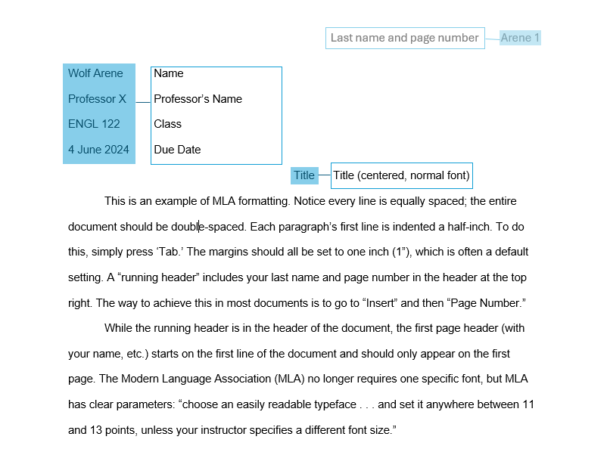
IN-TEXT CITATIONS
Each time information from a source is used in a paper (including quoting, summarizing, and paraphrasing) that source needs to be properly credited, aka cited. Crediting a source can be done in the text of a sentence or in parentheses at the end of a sentence. These parentheses are called “parenthetical references” or “in-text citations” or sometimes simply “citations.” Crediting a source in the text of a sentence is called a “narrative citation” or a “signal phrase.”

In MLA, proper crediting or citing of a source requires the first word from the corresponding Works Cited entry, regardless of whether the word appears in parentheses at the end of a sentence or in the text of a sentence itself. The example below illustrates the logic between Works Cited entries and in-text citations.

Work Cited
Berry, Wendell. “The Way of Ignorance.” The Way of Ignorance. Shoemaker & Hoard, 2005, pp. 53-67.

Parenthetical Citation
An experienced farmer and essayist presents a taxonomy of ignorance, including factual ignorance, moral ignorance, presumptuous ignorance, and fearful ignorance (Berry 53-67).

Narrative Citation (also called a “signal phrase”)
Berry’s essay describes a taxonomy of ignorance, including factual ignorance, moral ignorance, false confidence or presumptuous ignorance, and fearful ignorance (53-67).

Note: In the example above, because the writer has named the author in the sentence, the author doesn’t need to be named a second time in the parenthetical reference. And if this were a source without page numbers/identification, no parenthetical reference would be needed.

Narrative Citation using a Quote
To acknowledge that white privilege often allows for intentional ignorance, consider Amanda Shaffer’s confession that “my white skin . . . gave me the privilege not to see, not to hear, if I didn’t want to” (36).

Parenthetical Citation using a Quote
To acknowledge that white privilege often allows for intentional ignorance, a contributor to the essay collection Voices from the Rust Belt acknowledges that “my white skin . . . gave me the privilege not to see, not to hear, if I didn’t want to” (Shaffer 36).

Citing Two Authors
- Include both authors’ last names
- Via a parenthetical citation: (Strunk and White).
- Via narrative citation or signal phrase: Strunk and White’s Elements of Style . . .
- With page numbers via a parenthetical citation: (Strunk and White 54).
- With page numbers via narrative citation or signal phrase: Strunk and White’s Elements of Style . . . (54).

Citing Three or More Authors
- Include the name of only the first author listed, followed by “et al.” (Bullock et al.).

THE WORKS CITED PAGE
The Works Cited page is a list of all the sources cited in a paper.

FORMAT
- The Works Cited page is a new page after the last page of your essay
- Capitalize words in titles and proper nouns
- Note: MLA uses traditional punctuation, so ignore stylistic capitalization
- The words “Works Cited” are centered at the top of the page, not bolded
- Entries are double-spaced
- Entries have hanging indentation
- Everything after the first line is indented .5 inch.
- Titles of articles, chapters, episodes, etc., are in quotes
- Titles of books, magazines, journals, movies, etc., are italicized
- Alphabetize the citations according to the first word of each entry. This could be an author’s last name, a director, an organization, a title of a work, etc. Disregard the articles (“a,” “an,” and “the”) when alphabetizing.

WORKS CITED: EXAMPLES
Below is a sample Works Cited page followed by examples of several types of Works Cited entries and their corresponding parenthetical references.

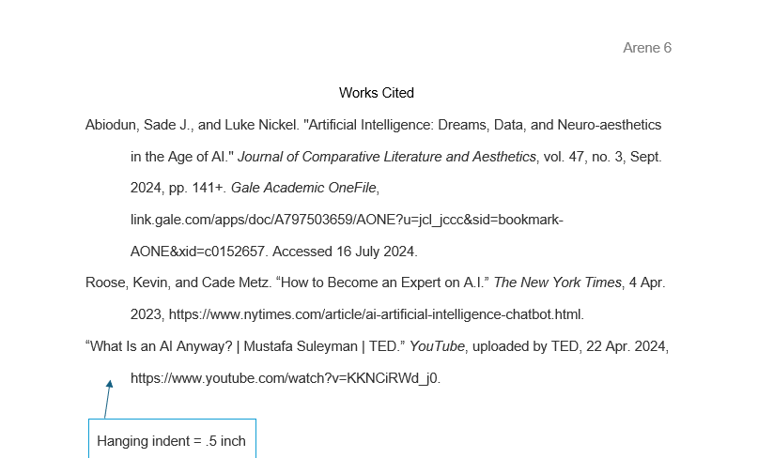

WORKS CITED EXAMPLES FOR COMMON TYPES OF SOURCES

ONLINE ARTICLES AND WEBPAGES
Full Citation on the Works Cited Page | Parenthetical Citation
Online Article or Section of a Webpage with an Author
Author’s Last Name, First Name. “Article or Section Title.” Website, Publisher, Date, url. | (Author’s Last Name)
Greenfieldboyce, Nell. “Wild Elephants May Have Names That Other Elephants Use to Call Them.” NPR, NPR, 11 June 2024, www.npr.org/2024/06/07/nx-s1-4994426/wild-elephants-individual-names. | (Greenfieldboyce)
Online Article or Section of a Webpage without an Author
“Is There a Cure for the Common Cold?” Riverside, Riverside Health System, 22 Apr. 2024, www.riversideonline.com/patients-and-visitors/healthy-you-blog/blog/i/is-there-a-cure-for-the-common-cold. | (“Is There a Cure”)

Full Citation on the Works Cited Page | Parenthetical Citation

Database Scholarly Journal Article (e.g. JSTOR, AcademicOne File, etc.)
Author’s Last Name, First Name. “Article Title,” Journal Title, vol. #, no. #, Date, page number(s). Database Title, doi or permalink. | (Author’s Last Name)
Vilarino, Natalia, et al. "Innovative detection methods for aquatic algal toxins and their presence in the food chain." Analytical and Bioanalytical Chemistry, vol. 405, no. 24, 15 Sept. 2013, pp. 7719+. Gale Academic OneFile, dx.doi.org.ezproxy.jccc.edu/10.1007/s00216-013-7108-6. | (Vilarino)

BOOKS
GENERAL FORMAT FOR BOOKS
Author’s Last Name, First Name. Book Title. Publisher, Publication Date.
Full Citation on the Works Cited Page | Parenthetical Citation
Book with One Author
Author’s Last Name, First Name. Book Title. Publisher, Publication Date. | (Author’s Last Name page #)
Hari, Johann. Stolen Focus: Why You Can’t Pay Attention–and How to Think Deeply Again. Crown Publishing, 2023. | (Hari 185)

Full Citation on the Works Cited Page | Parenthetical Citation

Book with Two Authors
First Author’s Last Name, First name, and Second Author’s First Name last name. Book Title. Publisher, Publication Date. | (First Author’s Last Name and Second Author’s Last Name page #)
Weidenborner, Stephen, and Domenick Caruso. Writing Research Papers. St. Martin’s Press, 1986. | (Weidenborner and Caruso 23)
Book with More Than Two Authors
First Author’s Last Name, First Name, et al. Book Title. Publisher, Publication Date. |  | (First Author’s Last Name et al. page number)
Wysocki, Anne Frances, et al. Writing New Media: Theory and Applications for Expanding the Teaching of Compostion. Utah State UP, 2004. |  | (Wysocki et al. 53)
A Reading in an Anthology Print Version (textbooks are often anthologies)
Author’s Last Name, First Name. “Title of Reading.” Title of Anthology, edition, edited by Editor’s Name, Publisher, Date, page numbers of reading. |  | (Author’s Last Name #)
Gold, Jonathan. “What Is a Burrito: A Primer.” 50 Essays: A Portable Anthology, 6th ed., edited by Samuel Cohen, Bedford/St. Martin’s, Boston, MA, 2020, pp. 193–195. |  | (Gold 194)

Full Citation on the Works Cited Page | Parenthetical Citation

A Reading in an Anthology Online Version
Author’s Last Name, First Name. “Title of Reading.” Title of Anthology, edition, edited by Editor’s Name, Publisher, Date, page numbers of reading, permalink. | (Author’s Last Name #)
Gold, Jonathan. “What Is a Burrito: A Primer.” 50 Essays: A Primer, 6th ed., Bedford/St. Martin’s, Boston, MA, 020, pp. 193–195, https://store.macmillanlearning.com/us/product/50-Essays/p/1319331653. | (Gold 194)

 | OTHER COMMON SOURCES
 | Online Video
 | Creator’s Last Name, First Name. “Video Title.” Website, uploaded by Channel Name, Upload Date, url. | (Author’s Last Name)
 | McGonigal, Jane. "Gaming and Productivity." YouTube, uploaded by Big Think, 3 July 2012, www.youtube.com/watch?v =mkdzy9bWW3E. | (McGonigal)
Film
Film Title. Directed by First Name Last Name, Production Company, Release Date. Source [if applicable]. |  | (Shortened Title)
Twin Peaks: Fire Walk with Me. Directed by David Lynch, CIBY Pictures, 1992. Amazon Prime Video. |  | (Twin Peaks)

Online Video
Creator’s Last Name, First Name. “Video Title.” Website, uploaded by Channel Name, Upload Date, url. | (Author’s Last Name)
McGonigal, Jane. "Gaming and Productivity." YouTube, uploaded by Big Think, 3 July 2012, www.youtube.com/watch?v =mkdzy9bWW3E. | (McGonigal)

A note on citation generators
Websites like easybib.com and citationmachine.com are often used by students to help them create Works Cited entries. These sites can save time and typing, but they are not perfect, so it is always essential to double check what they produce.
Citation generators offer two methods to assist students.
- Pasting a URL. Pasting a URL into a citation generator will auto-fill a template that includes boxes for author, title, etc. It is important to double check the information citation generators gather. Most of the time they are accurate, but they occasionally mis-identify a piece of information, which creates an inaccurate Work Cited entry. If this occurs, you can correct the mis-identified information prior to finalizing the citation.
- Filling in a template. For non-website sources, citation generators will provide a blank template, which the user fills in with the required info, author, title, etc. Once the template is filled in accurately, the citation generator will put all the information in the correct order with correct punctuation. Again, it’s important to double check the information you enter. Info entered in the wrong box on the template will produce an inaccurate or incorrectly punctuated Work Cited entry.

