Contents
Formatting Guidelines 1
Citing Sources 3
Author–Date System (Sciences and Social Sciences) 4
In-text Parenthetical Citations FAQs 4
References or Works Cited List FAQs 4
in-text parenthetical example, corresponding reference 6
and works cited entries 6
Notes and Bibliography System (Humanities) 12
Notes FAQs 12
Bibliography 13
Footnote Example 13
Endnote Example 14
Bibliography Example 14
Notes & Bibliography System Examples 14

The information in this handout is meant to be helpful, but it is not a substitute for The Chicago Manual of Style 17th Edition. Additional help may be found at https://www.chicagomanualofstyle.org/home.html

Formatting Guidelines
Margins: no less than 1” and no greater than 1.5”.
Font: The recommended typeface is something readable, such as Times New Roman or Arial. Use 11-12 pt. font.
Spacing: Double-space the paper, with the following exceptions:
- Single-space block quotations, table titles, and figure captions.
- Single-space notes and bibliography entries, but double space between entries.
Title Pages: If you use a title page, the title should be centered a third of the way down the page, and your name, class information, and date should follow several lines later.
When subtitles apply, end the title with a colon and place the subtitle on the line below the title. If you do not have a title page, include the title, your name, class information, and date, centered and double spaced at the top of the page. The title should be bold and in a larger font.

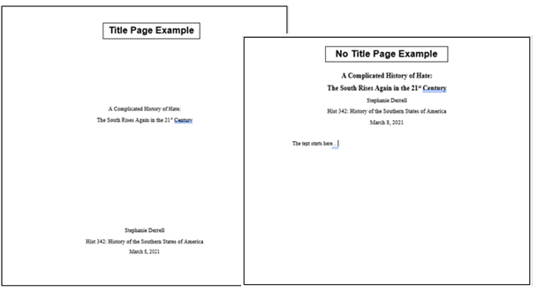

Sections: Longer papers may require sections or subheadings. Chicago allows you to devise your own format but be consistent. Put an extra line space before and after subheads, and avoid ending subheads with periods.

Citing Sources
What is a citation? If you use words or ideas that are not your own, you must cite (or state) where you found this information. To help your reader find information quickly, your sources must follow a specific citation system. Failure to cite sources correctly can lead to plagiarism.

Chicago-style source citations come in two varieties or systems:
- Author-date and references or works cited (used in the sciences and social sciences)
- Footnotes or endnotes and bibliography (used in humanities such as literature, history, and the arts)
Different instructors may have different requirements. Students should check with their instructors about their preferred documentation style for specific courses.

Author–Date System (Sciences and Social Sciences)
The author-date system is used more commonly in the sciences and social sciences, such as biology, geology, and economics. This system includes:
- In-text parenthetical citations: Sources are briefly cited in the text, usually in parentheses, by author’s last name and year of publication.
- References or Works Cited: Each parenthetical citation matches up with an entry in the References or Works Cited list, where full bibliographic information is provided.

In-text Parenthetical Citations FAQs
- Where do I put in-text parenthetical citations in the text? A parenthetical citation immediately follows quotes or cited material. It includes only the last name of the author(s) and the year of publication with no internal punctuation. If the citation is to a direct quotation, the parenthetical note may also include a comma just after the year, followed by a page number or other locator. The end punctuation of a sentence generally goes AFTER the parenthetical.
- What if my source has more than three authors? For up to three authors, all authors’ last names are included in the citation. For four or more authors, the first author’s last name is included, followed by et. al. and the year of publication.
- How do I cite works by the same author in a sentence? To cite additional works by the same author, do not repeat the author’s name; simply separate the years with a comma.
- How do I cite multiple works by different authors in one sentence? Multiple references may be included in a single parenthetical citation. They should be separated by semicolons and may be ordered either alphabetically or chronologically as long as the ordering is consistent throughout the work.

References or Works Cited List FAQs
- Where does the References or Works Cited list go? The source entries appear on a separate page at the end of the work, which is titled References or Works Cited.
- How are entries formatted? Each entry begins on a new line and is formatted with a hanging indent (first line is flush with the left margin, subsequent lines are indented five spaces).
- What is included in an entry? Entries include full publication information with the year immediately following the author’s name. City of publication should always be given; state, province, or country should be added if there are multiple citations with the same name. If the city is well known or the publisher name includes the state, the state abbreviation is not necessary.
- How do I format titles? Titles of works are capitalized headline-style, which means the first word and important words are capitalized. Titles of complete, self-contained works such as books and journals are italicized. Titles of shorter works inside the self-contained works such as articles and chapters are in quotation marks.
- How do I format authors’ names? Authors’ names should match how they appear on the title page of the work or at the head of the article or chapter. Only the first author’s name is inverted.
- How do I list entries? Reference entries are alphabetized by the author’s last name. Multiple entries for the same year are differentiated by the addition of a, b, etc. to the year of publication. Multiple entries by the same author or team of authors are organized by date of publication, from earliest to latest. After the first entry, the author’s name is replaced by a 3-em dash:
Woodward, David. The All-American Map: Wax Engraving and Its Influence on Cartography. Chicago: University of Chicago Press, 1977.
———, ed. Art and Cartography: Six Historical Essays. Chicago: University of Chicago Press, 1987.
———. Catalogue of Watermarks in Italian Printed Maps, ca. 15400-1600. Chicago: University of Chicago Press, 1996.

in-text parenthetical example, corresponding reference

and works cited entries
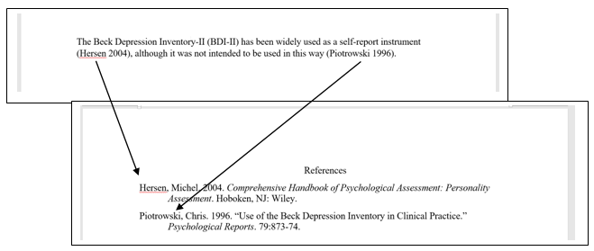

Author-Date System Examples
In this system, use in-text citations and a reference or works cited list.
BOOKS
 | In-text citation | References/Works Cited
 | Book with Single Author
 | (Last name year, page number) | Last name, first name. Year. Title. City published: Publisher.
 | (Brown 2010, 7) | Brown, Steven T. 2010. Tokyo Cyberpunk: Posthumanism in Japanese Visual Culture. New York: Palgrave MacMillian.
 | Book with Multiple Authors
 | (Last name, last name, and last name year, page number) | Last name, first name, first name last name, and first name last name. Year. Title. City published: Publisher.
 | (Christiensen, Roth, and Anthony 2004, 45) | Christensen, Clayton M., Erik A. Roth, and Scott D. Anthony. 2004. Seeing What’s Next: Using the Theories of Innovation to Predict Industry Change. Boston: Harvard Business School Press.
 | Book with Editors
 | (Last name and last name year, page number) | Last name, first name, and first name last name, eds. Year. Title. City published: Publisher.
 | (Kaplan and Pease 1993, 78) | Kaplan, Amy, and Donald E. Pease, eds. 1993. Cultures of United States Imperialism. Durham, NC: Duke University Press.
Chapter in Book with Editors
(Last name year, page number) |  | Last name, first name. Year. “Chapter Title.” In Title, edited by first name last name, page numbers. City published: Publisher.
(Pease 1998, 54) |  | Pease, Donald E. 1998. “José Martí, Alexis de Tocqueville, and the Politics of Displacement.” In José Martí’s “Our America”: From National to Hemispheric Cultural Studies, edited by Jeffery Belnap and Raúl Fernandez, 27–57. Durham, NC: Duke University Press.

In-text citation | References/Works Cited
E-Book
(Last name year, page number) | Last name, first name. Year. Title. City published: Publisher. Format.
(Cron 2012, chap. 3) | Cron, Lisa. 2012. Wired for Story. New York: Ten Speed Press. Kindle.

PERIODICALS/REPORTS
In-text citation | References/Works Cited
Journal/News/Magazine/Database Article
(Last name year, page number) | Last name, first name. Year. “Article Title.” Journal Title issue, (volume number): page numbers.
(Keinonen 2008, 35) | Keinonen, Turkka. 2008. “Design in Business: Views for the Nucleus and the Periphery.” Design Management Review 19 (3):30–36.
Report from an organization
(Organization year, page number) | Organization. Year. Title. document number:date. City published: Publisher.
(ISO 1997, 9) | ISO (International Organization for Standardization). 1997. Information and Documentation—Rules for the Abbreviation of Title Words and Titles of Publications. ISO 4:1997. Paris: ISO.

INTERNET SOURCES
In-text citation | References/Works Cited
News or magazine article
(Last name year, page number) | Last name, first name. Year. “Article Title.” Magazine Title, full date. url.
(Schulz 2015) | Schulz, Kathryn. 2015. “The Really Big One,” New Yorker, July 20, 2015. https://www.newyorker.com/magazine/2015/07/20/the-really-big-one.
Website
(Site name year) | Website. Year. “Page/Article Title.” Accessed full date. url.
(Portland State University n.d.) | Portland State University. n.d. “About Portland State University.” Accessed October 10, 2017. https://www.pdx.edu/about-portland-state-univerisity.
Blog
(Last name year) | Last name, first name. Year. “Post Title.” Website. Date. url.
(Brown 2017) | Brown, Kristen. 2017. “An FDA Panel Just Greenlit a Breakthrough Gene Therapy to Cure Blindness.” Gizmodo. October 12, 2017. https://gizmodo.com/an-fda-panel-just-greenlit-a-breakthrough-gene-therapy-1819412787.

In-text citation | References/Works Cited

Social Media
(Last name year) |  | Last name, first name (screen name if different). Year. “Post.” Platform, full date. url.
(Junot 2016) |  | Daiz, Junot. 2016. “Always surprises my students when I tell them that the ‘real’ medieval was more diverse than the fake ones most of us consume.” Facebook, February 24, 2016. https://www.facebook.com/junotdiaz.writer/posts/972495572815454.
X (formerly Twitter)
(Last name year) |  | Last name, first name (screen name). Year. “Post.” X, full date, time. url.
(Albini 2022) |  | Albini, Steve (@electricalWSOP). 2022. “People talking about a no-fly zone like it's a big net. It means shooting planes out of the air. Full-scale war.” X, March 16, 2022, 9:09 a.m. https://x.com/electricalWSOP/status/1504097456207900679
YouTube
(Last name year, page number) | Last name, first name (screen name). Year. “Post.” Twitter, full date, time. url.
(shapirolibrary 2017) | shapirolibrary. 2017. “Interview with Professor David Gou – 3D Printer Gripper.” YouTube Video, 1:10. December 19, 2017. https://youtu.be/SfsZjoD2Frk.

OTHER SOURCES
In-text citation | References/Works Cited
Government
(Government department year) | Government department. Year. Title. Publisher.
(Human Rights Commission of Pakistan 2010) | Human Rights Commission of Pakistan. 2010. The Upheaval in AJK Judiciary: Report of an HRCP Fact-Finding Mission. Human Rights Commission of Pakistan.
Unpublished Interview or Personal Communication
(Full name, communication type, full date) | Not needed.
(Julie Cantor, pers. comm.)

(health care worker, interview, July 31, 2017)

Notes and Bibliography System (Humanities)
The notes and bibliography system is preferred by many working in the humanities, such as literature, history, and the arts. The sources are cited in either numbered footnotes (at the bottom of the page) or endnotes (at the end of the essay), but not both. In Microsoft Word, the “insert footnote” or “insert endnote” tool in the references tab helps keep notes numbered and organized.
- Notes: The notes and bibliography system provides citation information in either footnotes or endnotes, which may be supplemented by a bibliography.
- Bibliography: When a bibliography is used, notes may use a shortened citation, giving only enough information (typically the author’s last name, shortened title, and locator information, such as a page or chapter number if necessary) to point readers to the corresponding entry in the bibliography. When no bibliography is given, the notes must include full citation information at the first mention of the work, with a shortened citation allowed thereafter.

Notes FAQs
- What goes in a note and how is it formatted? In the footnote or endnote, the elements are separated by commas. Publication information is enclosed in parentheses, and the author's name is not inverted. The note ends with a period.
- How do I format note numbers in the text? In the text, the corresponding note number is superscripted.
- Where do the notes in the text go? Note numbers appear at the end of the sentence or clause. They follow all punctuation except the dash, which they precede. Except in rare cases, note numbers generally follow closing parentheses.
- What else can go in notes? Notes may also be used to provide additional commentary or peripheral discussion, but such substantive notes should be carefully regulated to avoid overloading the text.

Bibliography
- Where does a Bibliography go? The source entries appear on a separate page at the end of the work and is typically titled Bibliography.
- What is in an entry? Entries include full publication information. City of publication should always be given; state, province, or country should be added if there are multiple citations with the same name. If the city is well known or the publisher name includes the state, the state abbreviation is not necessary. The date appears either at the end of the entry or near the end, depending on the type of source.
- How are entries formatted? The elements of each entry are separated by periods, and publication information is not in parentheses. Organization of the bibliography follows the same rules as the reference list in the author-date system, including the use of the 3-em dash to replace author’s names when there are several entries by the same author.

Footnote Example
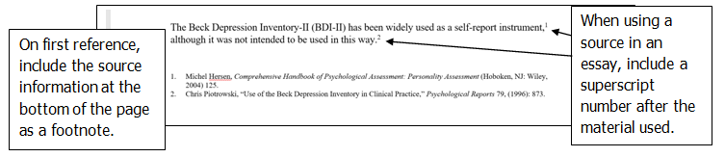

Endnote Example
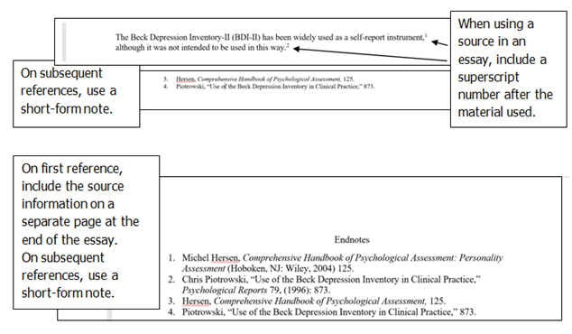

Bibliography Example
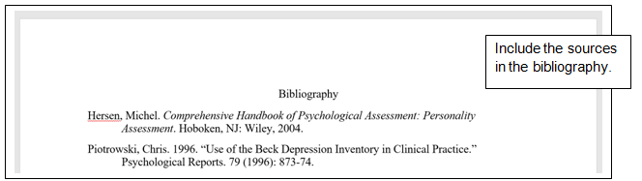

Notes & Bibliography System Examples
In this system, either use footnotes or endnotes (but not both) and a bibliography.

BOOKS
In-text citation | Short-Form Note (subsequent references)  &  Bibliography
Book with Single Author
First and last name, Title, (City published: Publisher, year), page number. | Last name, Shortened Title, page number.  &  Last name, first name. Title. City published: Publisher, year.
- Steven T. Brown, Tokyo Cyberpunk: Posthumanism in Japanese Visual Culture (New York: Palgrave MacMillian, 2010), 124. | - Brown, Tokyo Cyberpunk, 11.  &  Brown, Steven T. Tokyo Cyberpunk: Posthumanism in Japanese Visual Culture. New York: Palgrave MacMillian, 2010.

In-text citation | Short-Form Note (subsequent references)  &  Bibliography

Book with Multiple Authors
First name last name, first name last name, first name, and first name last name, Title, (City published: Publisher, year), page number. | Last name, last name, and last name, Shortened Title, page number.  &  Last name, first name, first name last name, and first name last name. Title. City published: Publisher, year.
- Clayton M. Christensen, Erik A. Roth, and Scott D. Anthony, Seeing What’s Next: Using the Theories of Innovation to Predict Industry Change. (Boston: Harvard Business School Press, 2004), 112–21. | - Christensen, Roth, and Anthony, Seeing What’s Next, 120.  &  Christensen, Clayton M., Erik A. Roth, and Scott D. Anthony. Seeing What’s Next: Using the Theories of Innovation to Predict Industry Change. Boston: Harvard Business School Press, 2004.

Book with Editors
First name last name and first name last name, eds., Title, (City published: Publisher, year), page number. | Last name and last name, Shortened Title, page number.  &  Last name, first name and first name last name, eds. Title. City published: Publisher, year.
- Amy Kaplan and Donald E. Pease, eds. Cultures of United States Imperialism (Durham, NC: Duke University Press), 1993. | - Kaplan and Pease, eds. Cultures of United States Imperialism. University Press), 1993.  &  Kaplan, Amy, and Donald E. Pease, eds. Cultures of United States Imperialism. Durham, NC: Duke University Press, 1993.

Chapter in Book with Editors
First name last name, “Chapter Title,” in Book Title, eds. first name last name and first name last name, (City published: Publisher, year), page number. | Last name, “Chapter Title,” page number.  &  Last name, first name. “Chapter Title.” In Book Title, edited by first name last name and first name last name, page numbers. City published: Publisher, year.
- Donald E. Pease, “José Martí, Alexis de Tocqueville, and the Politics of Displacement,” in José Martí’s “Our America”: From National to Hemispheric Cultural Studies, eds. Jeffery Belnap and Raúl Fernandez (Durham, NC: Duke University Press, 1998), 29. | - Pease, “José Martí,” 43.  &  Pease, Donald E. “José Martí, Alexis de Tocqueville, and the Politics of Displacement.” In José Martí’s “Our America”: From National to Hemispheric Cultural Studies, edited by Jeffery Belnap and Raúl Fernandez, 27–57. Durham, NC: Duke University Press, 1998.
E-Book
First and last name, Title, (City published: Publisher, year), page number. Format. | Last name, Shortened Title, page number.  &  Last name, first name. Title. City published: Publisher, year. Format.
- Lisa Cron, Wired for Story (New York: Ten Speed Press, 2012), chap. 3, Kindle. | - Cron, Wired for Story, chap. 4.  &  Cron, Lisa. Wired for Story. New York: Ten Speed Press, 2012. Kindle.

PERIODICALS/REPORTS
In-text citation | Short-Form Note (subsequent references)  &  Bibliography
Journal/News/Magazine/Database Article
First name last name, “Article Title,” Journal Title issue, volume number (year or full date): page number. | Last name, “Shortened Article Title,” page number.  &  Last name, first name. “Article Title.” Journal Title issue, volume number (year or full date): page numbers.
- Turkka Keinonen, “Design in Business: Views for the Nucleus and the Periphery,” Design Management Review 19, no. 3 (2008): 33. | - Keinonen, “Design in Business,” 31.  &  Keinonen, Turkka. “Design in Business: Views for the Nucleus and the Periphery.” Design Management Review 19, no. 3 (2008): 30–36.
Report from an organization
Organization, Title, document number (City published: Publisher, year or full date), page number. | Organization, Shortened Title, page number.  &  Organization. Title. document number:date. City published: Publisher, year or full date.
- ISO, Information and Documentation—Rules for the Abbreviation of Title Words and Titles of Publications. (ISO 4:1997. Paris: ISO, 1997), 14. | - ISO, Information and Documentation, 12.  &  ISO (International Organization for Standardization). Information and Documentation—Rules for the Abbreviation of Title Words and Titles of Publications. ISO 4:1997. Paris: ISO, 1997.

INTERNET SOURCES
In-text citation | Short-Form Note (subsequent references)  &  Bibliography
Journal Article
First name last name, “Article Title,” Journal Title issue, volume number (year or full date): page number, doi address. | Last name, “Shortened Article Title,” page number.  &  Last name, first name. “Article Title.” Journal Title issue, volume number (year or full date): page numbers. doi address
- Turkka Keinonen, “Design in Business: Views for the Nucleus and the Periphery,” Design Management Review 19, no. 3 (2008): 33. https://doi.org/10.1111/j.1948-7169.2008.tb00126. | - Keinonen, “Design in Business,” 31.  &  Keinonen, Turkka. “Design in Business: Views for the Nucleus and the Periphery.” Design Management Review 19, no. 3 (2008): 30–36. https://doi.org/10.1111/j.1948-7169.2008.tb00126.

Website
First name last name, “Article Title,” Magazine Title, full date, url. | Last name, “Article Title.”  &  Last name, first name. “Article Title.” Magazine Title, full date. url.
- Kathryn Schulz, “The Really Big One,” New Yorker, July 20, 2015, https://www.newyorker.com/magazine/2015/07/20/the-really-big-one. | - Schulz, “The Really Big One.”  &  Schulz, Kathryn. “The Really Big One,” New Yorker, July 20, 2015. https://www.newyorker.com/magazine/2015/07/20/the-really-big-one.
Website
“Page/Article Title,” Website, accessed full date, url. | Same as note  &  Website. “Page/Article Title.” Accessed full date. url.
- “About Portland State University,” Portland State University, accessed October 10, 2017, https://www.pdx.edu/about-portland-state-univerisity. | Same as note  &  Portland State University. “About Portland State University.” Accessed October 10, 2017. https://www.pdx.edu/about-portland-state-univerisity.

Blog
First name last name, “Post Title,” Website. Full date, url. | Same as note.  &  Last name, first name. “Post Title.” Website. Full date. url.
- Kristen Brown, “An FDA Panel Just Greenlit a Breakthrough Gene Therapy to Cure Blindness,” Gizmodo. October 12, 2017, https://gizmodo.com/an-fda-panel-just-greenlit-a-breakthrough-gene-therapy-1819412787. | Same as note.  &  Brown, Kristen. “An FDA Panel Just Greenlit a Breakthrough Gene Therapy to Cure Blindness.” Gizmodo. October 12, 2017. https://gizmodo.com/an-fda-panel-just-greenlit-a-breakthrough-gene-therapy-1819412787.
Social Media
First name last name, “Post.” Platform, full date. url. | Same as note.  &  Last name, first name (screen name if different). “Post.” Platform, full date. url.
- Junot Daiz, “Always surprises my students when I tell them that the ‘real’ medieval was more diverse than the fake ones most of us consume,” Facebook, February 24, 2016, https://www.facebook.com/junotdiaz.writer/posts/972495572815454. | Same as note.  &  Daiz, Junot. “Always surprises my students when I tell them that the ‘real’ medieval was more diverse than the fake ones most of us consume.” Facebook, February 24, 2016. https://www.facebook.com/junotdiaz
X (formerly Twitter)
First name last name (screen name), “Post,” Twitter, full date, time, url. | Same as note.  &  Last name, first name (screen name). “Post.” Twitter, full date, time. url.
- Albini, Steve (@electricalWSOP). 2022. “People talking about a no-fly zone like it's a big net. It means shooting planes out of the air. Full-scale war.” X, March 16, 2022, 9:09 a.m. https://x.com/electricalWSOP/status/1504097456207900679 | Albini, Steve (@electricalWSOP). 2022. “People talking about a no-fly zone like it's a big net. It means shooting planes out of the air. Full-scale war.” X, March 16, 2022, 9:09 a.m. https://x.com/electricalWSOP/status/1504097456207900679
YouTube
Screen name, “Video Title.” YouTube Video, time stamp. Full date, url. | Same as note.  &  Screen name. “Video Title.” YouTube Video, time stamp. Full date. url.
- shapirolibrary, “Interview with Professor David Gou—3D Printer Gripper,” YouTube Video, 1:10. December 19, 2017, https://youtu.be/SfsZjoD2Frk. | Same as note.  &  shapirolibrary. 2017. “Interview with Professor David Gou—3D Printer Gripper.” YouTube Video, 1:10. December 19, 2017. https://youtu.be/SfsZjoD2Frk.

OTHER SOURCES
In-text citation | References/Works Cited
Government
Government Department, Title. (Publisher, year), page number. | Government Department, Title, page number.  &  Government Department. Title. Publisher, year.
- Human Rights Commission of Pakistan, The Upheaval in AJK Judiciary: Report of an HRCP Fact-Finding Mission (Human Rights Commission of Pakistan, 2010), 11. | - Human Rights Commission of Pakistan, Upheaval in AJK Judiciary, 11–12.  &  Human Rights Commission of Pakistan. The Upheaval in AJK Judiciary: Report of an HRCP Fact-Finding Mission. Human Rights Commission of Pakistan, 2010.
Unpublished Interview or Personal Communication
First name last name, type of communication, full date. | Same as note.  &  Not needed.
- Julie Cantor, email message to author, April 23, 2017.  - Interview with health care worker, July 31, 2017. | Same as note.  &  Not needed.

