Chicago Manual of Style (CMOS)
Turabian Style

The information in this handout is meant to be helpful, but it is not a substitute for The Chicago Manual of Style 17th Edition. Additional help may be found at https://www.chicagomanualofstyle.org/home.html.

Formatting Guidelines
Margins: no less than 1” and no greater than 1.5”.
Font: The recommended typeface is something readable, such as Times New Roman or Arial. Use 11-12 pt. font.
Spacing: Double-space the paper, with the following exceptions:
- Single-space block quotations, table titles, and figure captions.
- Single-space notes and bibliography entries, but double space between entries.
Title Pages: If you use a title page, the title should be centered a third of the way down the page, and your name, class information, and date should follow several lines later. When subtitles apply, end the title with a colon and place the subtitle on the line below the title.
If you do not have a title page, include the title, your name, class information, and date centered and double spaced at the top of the page. The tile should be bold and in larger font.
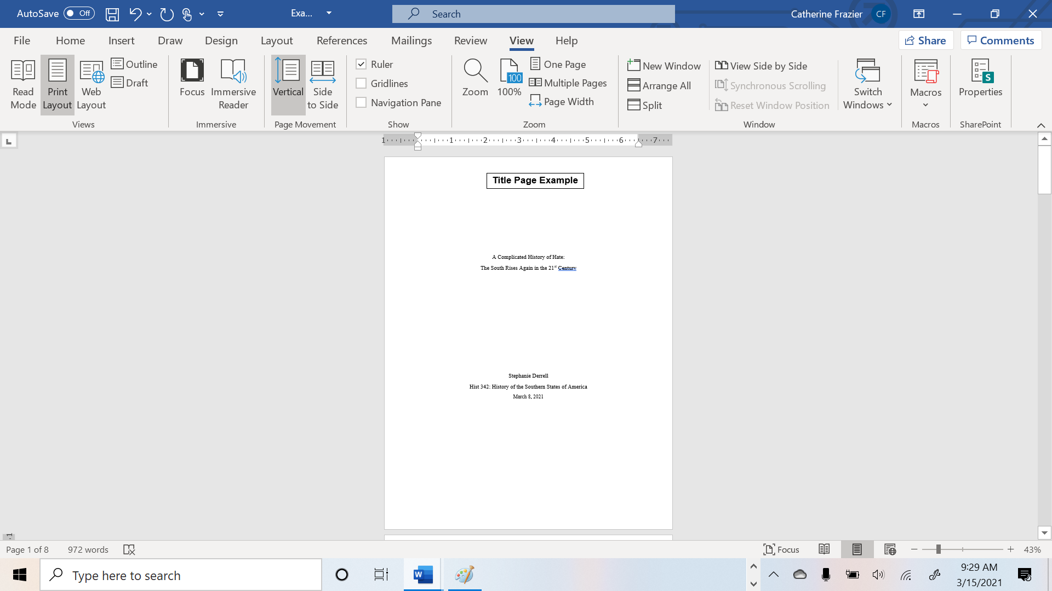
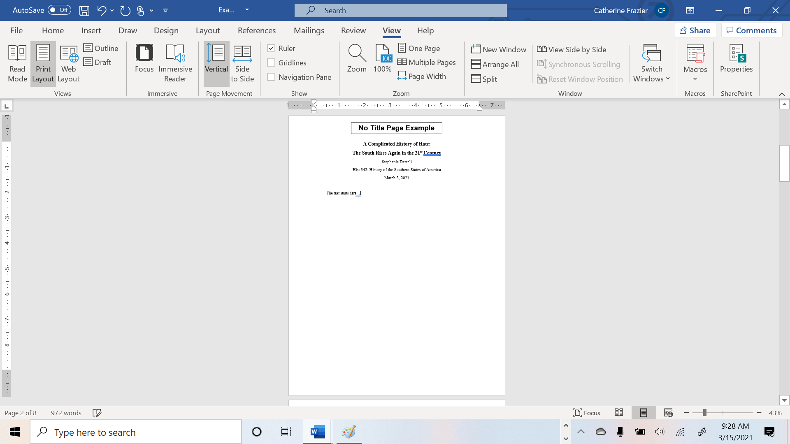
Sections: Longer papers may require sections or subheadings. Chicago allows you to devise your own format but be consistent. Put an extra line space before and after subheads, and avoid ending subheads with periods.

Citing Sources
What is a citation? If you use words or ideas that are not your own, you must cite (or state) where you found this information. To help your reader find information quickly, your sources must follow a specific citation system. Failure to cite sources correctly can lead to plagiarism.
Chicago-style source citations come in two varieties or systems:
- Author-date and references or works cited (mostly used in the sciences and social sciences)
- Footnotes or endnotes and bibliography (used in humanities such as literature, history, and the arts)
Different instructors may have different requirements. Students should check with their instructors about their preferred documentation style for specific courses.
Author–Date System (Sciences and Social Sciences)
The author-date system is used more commonly in the sciences and social sciences, such as biology, geology, and economics. This system includes:
- In-text parenthetical citations: Sources are briefly cited in the text, usually in parentheses, by author’s last name and year of publication.
- References or Works Cited: Each parenthetical citation matches up with an entry in the References or Works Cited list, where full bibliographic information is provided.

In-text Parenthetical Citations FAQs
- Where do I put in-text parenthetical citations in the text? A parenthetical citation immediately follows quotes or cited material. It includes only the last name of the author(s) and the year of publication with no internal punctuation. If the citation is to a direct quotation, the parenthetical note may also include a comma just after the year, followed by a page number or other locator. The end punctuation of a sentence generally goes AFTER the parenthetical.
- What if my source has more than three authors? For up to three authors, all authors’ last names are included in the citation. For four or more authors, the first author’s last name is included, followed by et. al. and the year of publication.
- How do I cite works by the same author in a sentence? To cite additional works by the same author, do not repeat the author’s name; simply separate the years with a comma.
- How do I cite multiple works by different authors in one sentence? Multiple references may be included in a single parenthetical citation. They should be separated by semicolons and may be ordered either alphabetically or chronologically as long as the ordering is consistent throughout the work.

References or Works Cited List FAQs
- Where does the References or Works Cited list go? The source entries appear on a separate page at the end of the work and is titled References or Works Cited.
- How are entries formatted? Each entry begins on a new line and is formatted with a hanging indent (first line is flush with the left margin, subsequent lines are indented five spaces).
- What is included in an entry? Entries include full publication information with the year immediately following the author’s name. City of publication should always be given; state, province, or country should be added if there are multiple citations with the same name. If the city is well known or the publisher name includes the state, the state abbreviation is not necessary.
- How do I format titles? Titles of works are capitalized headline-style, which means the first word and important words are capitalized. Titles of complete, self-contained works such as books and journals are italicized. Titles of shorter works inside the self-contained works such as articles and chapters are in quotation marks.
- How do I format authors’ names? Authors’ names should match how they appear on the title page of the work or at the head of the article or chapter. Only the first author’s name is inverted.
- How do I list entries? Reference entries are alphabetized by the author’s last name. Multiple entries for the same year are differentiated by the addition of a, b, etc. to the year of publication. Multiple entries by the same author or team of authors are organized by date of publication, from earliest to latest. After the first entry, the author’s name is replaced by a 3-em dash:
Woodward, David. The All-American Map: Wax Engraving and Its Influence on Cartography. Chicago: University of Chicago Press, 1977.
———, ed. Art and Cartography: Six Historical Essays. Chicago: University of Chicago Press, 1987.
———. Catalogue of Watermarks in Italian Printed Maps, ca. 15400-1600. Chicago: University of Chicago Press, 1996.
In-Text Parenthetical Example with
Corresponding Reference or Works Cited Entries
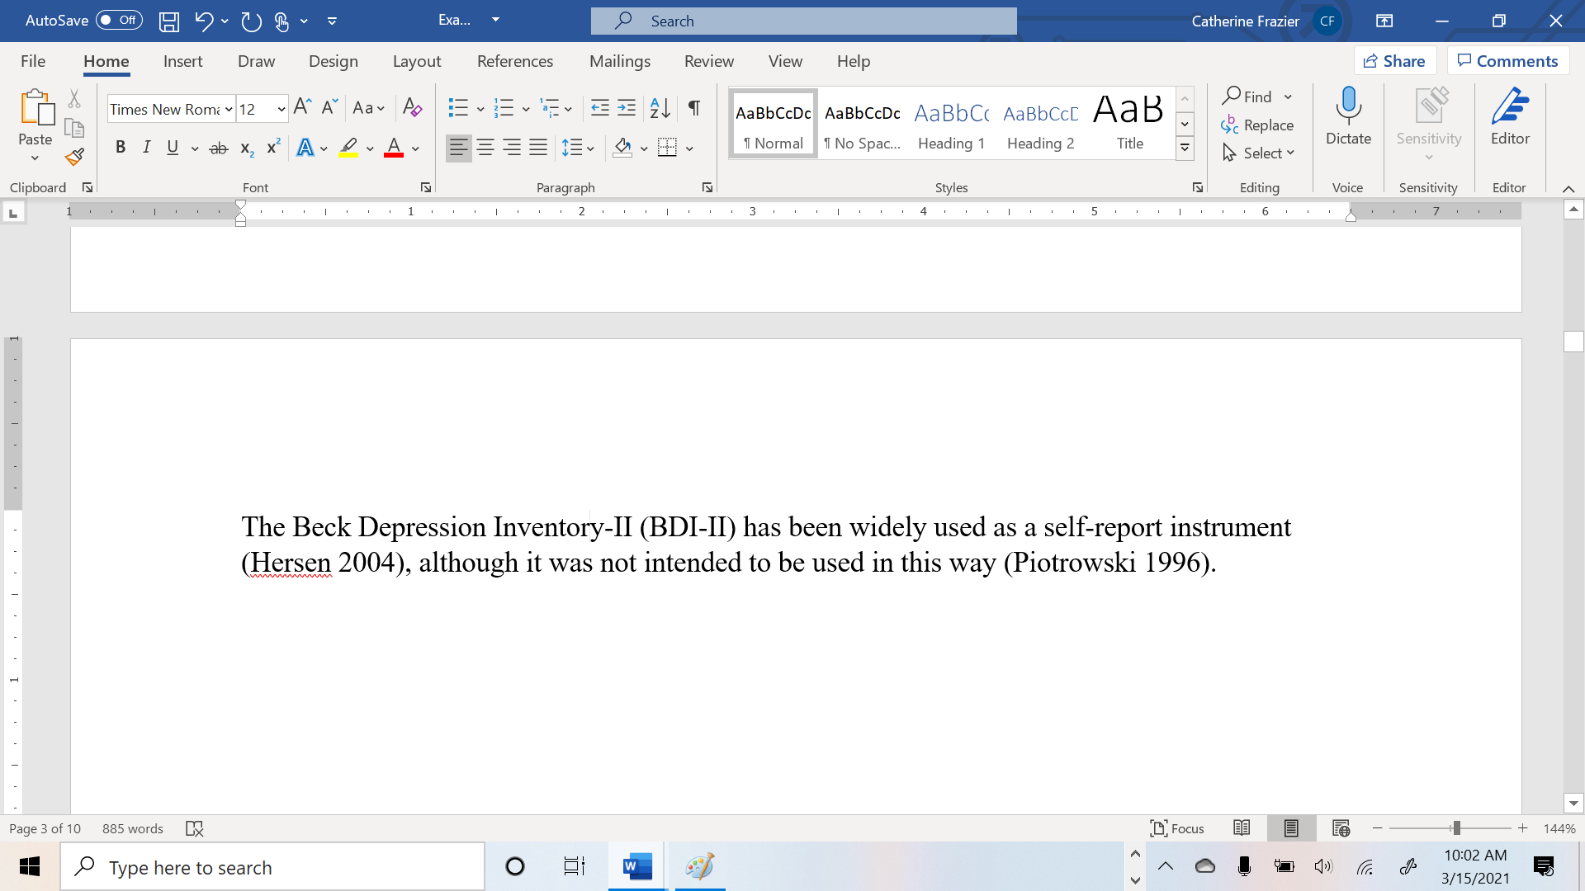
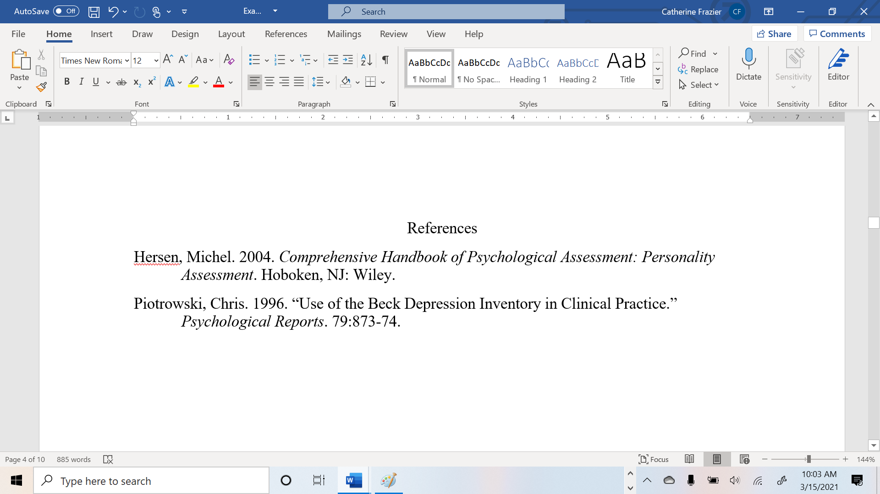

Author-Date System Examples
In this system, use in-text citations and a reference or works cited list.
BOOKS
 | In-text citation | References/Works Cited
 | Book with Single Author
 | (Last name year, page number) | Last name, first name. Year. Title. City published: Publisher.
 | (Brown 2010, 7) | Brown, Steven T. 2010. Tokyo Cyberpunk: Posthumanism in Japanese Visual Culture. New York: Palgrave MacMillian.
 | Book with Multiple Authors
 | (Last name, last name, and last name year, page number) | Last name, first name, first name last name, and first name last name. Year. Title. City published: Publisher.
 | (Christiensen, Roth, and Anthony 2004, 45) | Christensen, Clayton M., Erik A. Roth, and Scott D. Anthony. 2004. Seeing What’s Next: Using the Theories of Innovation to Predict Industry Change. Boston: Harvard Business School Press.
 | Book with Editors
 | (Last name and last name year, page number) | Last name, first name, and first name last name, eds. Year. Title. City published: Publisher.
 | (Kaplan and Pease 1993, 78) | Kaplan, Amy, and Donald E. Pease, eds. 1993. Cultures of United States Imperialism. Durham, NC: Duke University Press.
Chapter in Book with Editors
(Last name year, page number) |  | Last name, first name. Year. “Chapter Title.” In Title, edited by first name last name, page numbers. City published: Publisher.
(Pease 1998, 54) |  | Pease, Donald E. 1998. “José Martí, Alexis de Tocqueville, and the Politics of Displacement.” In José Martí’s “Our America”: From National to Hemispheric Cultural Studies, edited by Jeffery Belnap and Raúl Fernandez, 27–57. Durham, NC: Duke University Press.

In-text citation | References/Works Cited
E-Book
(Last name year, page number) | Last name, first name. Year. Title. City published: Publisher. Format.
(Cron 2012, chap. 3) | Cron, Lisa. 2012. Wired for Story. New York: Ten Speed Press. Kindle.

PERIODICALS/REPORTS
In-text citation | References/Works Cited
Journal/News/Magazine/Database Article
(Last name year, page number) | Last name, first name. Year. “Article Title.” Journal Title issue, (volume number): page numbers.
(Keinonen 2008, 35) | Keinonen, Turkka. 2008. “Design in Business: Views for the Nucleus and the Periphery.” Design Management Review 19 (3):30–36.
Report from an organization
(Organization year, page number) | Organization. Year. Title. document number:date. City published: Publisher.
(ISO 1997, 9) | ISO (International Organization for Standardization). 1997. Information and Documentation—Rules for the Abbreviation of Title Words and Titles of Publications. ISO 4:1997. Paris: ISO.

INTERNET SOURCES
 | In-text citation | References/Works Cited
 | News or magazine article
 | (Last name year, page number) | Last name, first name. Year. “Article Title.” Magazine Title, full date. url.
 | (Schulz 2015) | Schulz, Kathryn. 2015. “The Really Big One,” New Yorker, July 20, 2015. https://www.newyorker.com/magazine/2015/07/20/the-really-big-one.
 | Website
 | (Site name year) | Website. Year. “Page/Article Title.” Accessed full date. url.
 | (Portland State University n.d.) | Portland State University. n.d. “About Portland State University.” Accessed October 10, 2017. https://www.pdx.edu/about-portland-state-univerisity.
 | Blog
 | (Last name year) | Last name, first name. Year. “Post Title.” Website. Date. url.
 | (Brown 2017) | Brown, Kristen. 2017. “An FDA Panel Just Greenlit a Breakthrough Gene Therapy to Cure Blindness.” Gizmodo. October 12, 2017. https://gizmodo.com/an-fda-panel-just-greenlit-a-breakthrough-gene-therapy-1819412787.
Social Media
(Last name year) |  | Last name, first name (screen name if different). Year. “Post.” Platform, full date. url.
(Junot 2016) |  | Daiz, Junot. 2016. “Always surprises my students when I tell them that the ‘real’ medieval was more diverse than the fake ones most of us consume.” Facebook, February 24, 2016. https://www.facebook.com/junotdiaz.writer/posts/972495572815454.

In-text citation |  | References/Works Cited
X (formerly Twitter)
(Last name year) | Last name, first name (screen name). Year. “Post.” X, full date, time. url.
(Albini 2022) | Albini, Steve (@electricalWSOP). 2022. “People talking about a no-fly zone like it's a big net. It means shooting planes out of the air. Full-scale war.” X, March 16, 2022, 9:09 a.m. https://x.com/electricalWSOP/status/1504097456207900679
YouTube
(Last name year, page number) |  | Last name, first name (screen name). Year. “Post.” Twitter, full date, time. url.
(shapirolibrary 2017) |  | shapirolibrary. 2017. “Interview with Professor David Gou – 3D Printer Gripper.” YouTube Video, 1:10. December 19, 2017. https://youtu.be/SfsZjoD2Frk.

OTHER SOURCES
In-text citation | References/Works Cited
Government
(Government department year) | Government department. Year. Title. Publisher.
(Human Rights Commission of Pakistan 2010) | Human Rights Commission of Pakistan. 2010. The Upheaval in AJK Judiciary: Report of an HRCP Fact-Finding Mission. Human Rights Commission of Pakistan.
Unpublished Interview or Personal Communication
(Full name, communication type, full date) | Not needed.
(Julie Cantor, pers. comm.)

(health care worker, interview, July 31, 2017)

