American Psychological Association (APA) Quick Reference Guide

Contents
GENERAL GUIDELINES 2
IN-TEXT CITATIONS, QUOTES, AND BLOCK QUOTES 2
Parenthetical Citations 2
Narrative Citations 2
Citing Two Authors 2
Citing Three or More Authors 2
Direct Quotations of Material with Page Numbers 3
THE REFERENCES PAGE 3
SCHOLARLY JOURNALS 4
General Format for Journal References 4
BOOKS 5
General Format for Journal References 5
ONLINE SOURCES 6
SAMPLE TITLE AND REFERENCE PAGES 8

GENERAL GUIDELINES
- All pages have a one-inch margin.
- Double-space the entire document.
- APA does not specify a font. Check with your instructor for their preferred font.
- Indent each paragraph .5 inch. The Tab key is usually defaulted to this.
- Include one space after each sentence.
- Italicize whole works, books, and websites.
- Use a hanging indent for each reference on the References page.
- Do not include the phrase “Retrieved from” or “Accessed from” when using a DOI or URL in the references list.
- Do not add a period at the end of the DOI or URL.

IN-TEXT CITATIONS, QUOTES, AND BLOCK QUOTES
In-text citations are abbreviated forms of the full citations on the References page.
In-text citations can be either parenthetical or narrative.

Parenthetical Citations
Falsely balanced news coverage can distort the public’s perception of expert consensus on an issue (Koehler, 2016).

Narrative Citations
Koehler (2016) noted the dangers of falsely balanced news coverage.

Citing Two Authors
- When the citation is narrative, use the word “and”.
- When the citation is parenthetical, use an ampersand: “&”.
Jones and Smith (1991) suggest that street violence injures more people than the immediate victims.
Street violence hurts more than the immediate victims (Jones & Smith, 1991)

Citing Three or More Authors
Include the name of only the first author, followed by “et al.", in every citation, including the first citation, unless doing so would create ambiguity.

Direct Quotations of Material with Page Numbers
(Armstrong, 2015, pp. 3-17) (Kowalsky, 1994, 4, 27, 92-94)

THE REFERENCES PAGE
- The References page is the last section of the paper.
- It begins on a new page.
- The word “References” is centered at the top of the page, in unbolded font.
- Pagination is continuous with your paper.
- Alphabetize the sources by the author's or editor’s last name, or the first key word, such as in the name of the article, book, or website.
- If there are multiple authors, use the ampersand (“&”) between names.
- Double-space all entries.
- Introduce each reference with a hanging indent.
- Use italics for whole works, such as books, journals, websites, etc.
- Citations on the References page:
  - Follow some variation of Author, Date, Title, Source.
  - Note that “author” may or may not be a person. They could be organizations, groups, composers, artists, etc

SCHOLARLY JOURNALS

General Format for Journal References
Author, F. I. & Author, B. (Year of publication). Title of article in sentence case. Title of Periodical with All Major Words Capitalized, volume number (issue number), xx-xx. doi or url
- Note: When using a quote or idea from a specific page, add a page number in the parenthetical citation.
 | Full Citation on the Works Cited Page | Parenthetical Citation
Database or Online Journal Article
Last Name, First and Middle Initial. (Year of Publication). Article Title. Journal Title, Volume Number(Issue Number), Page Numbers. doi |  |  | (Author’s Last Name, year)
Baniya, S., & Weech, S. (2019). Data and experience design: Negotiating community-oriented digital research with service-learning. Purdue Journal of Service-Learning and International Engagement, 6(1), 11-16. https://doi.org /10.5703.1288284316979 |  |  | (Baniya and Weech, 2019, p. 16)

BOOKS

General Format for Journal References
Author, F. I. & Author, B. (Year of publication). Title of article in sentence case. Title of Periodical with All Major Words Capitalized, volume number (issue number), xx-xx. doi or url
- Note: When using a quote or idea from a specific page, add a page number in the parenthetical citation.
Full Citation on the Works Cited Page | Parenthetical Citation
Book with One Author
Last Name, First and Middle Initial. (Year of Publication). Book Title (edition). Publisher. |  | (Author’s Last Name, year)
Sapolsky, R. M. (2017). Behave: The biology of humans at our best and worst. Penguin Books. |  | (Sapolsky, 2017)
Book with Multiple Authors (2 to 20)
Last Name, First and Middle Initial, . . . [up to 19 additional authors], Last Name, First and Middle Initial. (Year of Publication). Book Title (edition). Publisher.  Note: Include up to 20 authors by listing their last name, first and middle initial, followed by a comma. Before the final author, use an ampersand (&) before the author's name. |  | (First Author’s Last Name et al., year)
Rivano, N. S., Hoson, A., & Stallings, B. (2001). Regional integration and economic development. Palgrave. |  | (Rivano et al., 2017)

ONLINE SOURCES
Note: Include a “Retrieved” date for an online source only if:
- It does not have a publication date
- It appears to have been altered or removed since you first accessed it
- It is regularly updated (Breaking news, weather forecasts, stock market reports, etc.)
 | Full Citation on the Works Cited Page | Parenthetical Citation
Webpage with an Author
Last Name, First and Middle Initial. (Publication Year, Month Date). Webpage Title. Website Name. url |  |  | (Author’s Last Name, year)
Martin Lillie, C. M. (2016, December 29). Be kind to yourself: How self-compassion can improve your resiliency. Mayo Clinic. https://www.mayo.clinic.org/healthy-lifestyle/adult-health/in-depth/self-compassion-can-improve-your-resiliency/art-202667193 |  |  | (Martin Lillie, 2019)
Webpage without an Author
Webpage Title. (Publication Year, Month Date). Website Name. Retrieved Month Date, Year, from url |  |  | (Shortened webpage Title, year)
Tuscan white bean pasta. (2018, February 25). Budgetbytes. Retrieved March 18, 2020, from https://www.budget bytes. com/tuscan-white-bean-pasta/ |  |  | (Tuscan, 2018)

Full Citation on the Works Cited Page | Parenthetical Citation
Webpage without a Date
Last Name, First and Middle Initial. (n.d.) Webpage Title. Website Name. url |  | (Author’s Last Name, n.d.)
National Alliance on Mental Illness. (n.d.). Mental health conditions. https://www.nami.org/Learn-More/Mental-Heatlh-Conditions |  | (National Alliance on Mental Health, n.d.)
Online Periodical
Last Name, First and Middle Initial. (Publication Year, Month Date). Article Title. Publication Title. url |  | (Author’s Last Name, year)
Strom, S. (2014, October 9). Farmers gain weapon against devastating pig virus. The New York Times. http://www.nytimes.com/ |  | (Strom, 2014)

SAMPLE TITLE AND REFERENCE PAGES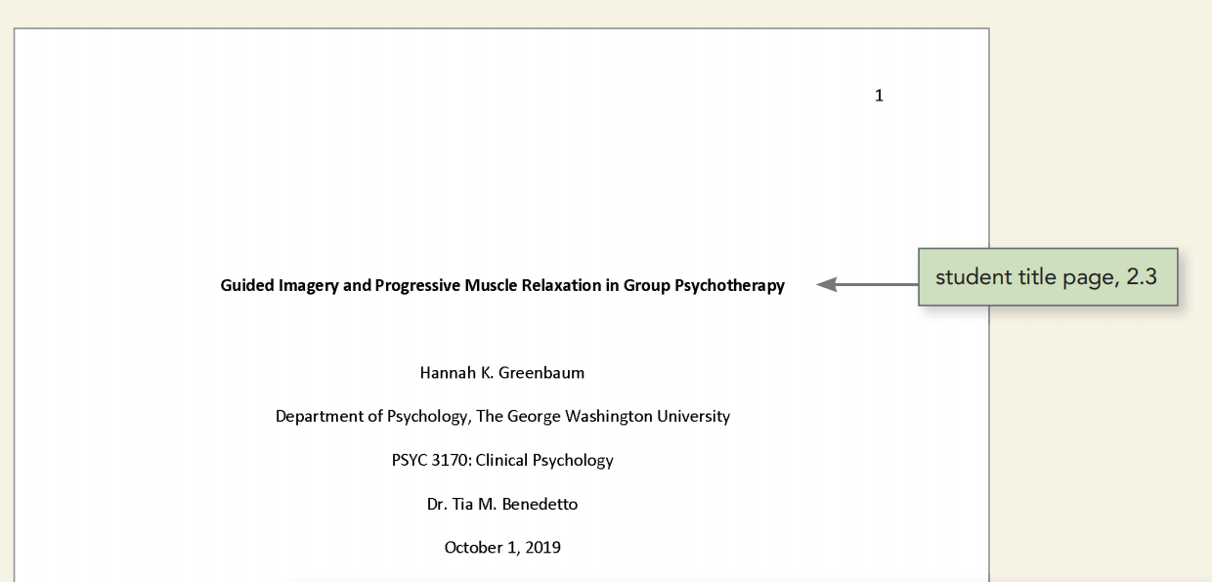
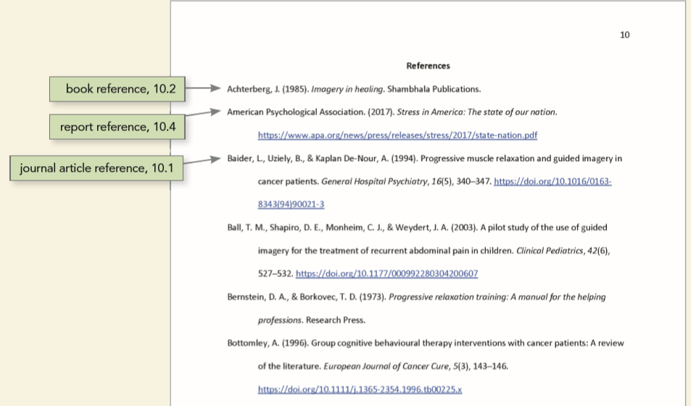

Full Citation on the Works Cited Page | Parenthetical Citation

