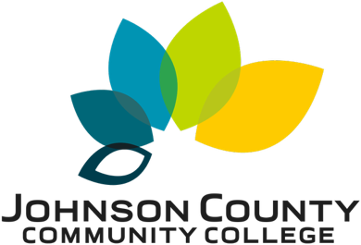

2025 Annual Report

On Learning Outcomes

Table of Contents
Introduction 4
Methods 4
Executive Summary 4
General Education Reporting – Student Learning Outcomes (SLOs) 6
Summative Data Tables for General Education 7
Chart 1: General Education Assessment – By Outcome AY24-25 8
Chart 2: General Education Assessment – By Outcome AY23-24 8
Chart 3: General Education Outcomes – Number of Students by SLO AY24-25 9
Chart 4: General Education Outcomes – Number of Students by SLO AY23-24 9
Chart 5: Totals by Bloom’s Level 10
Career and Technical Education & Non-General Education Reporting – Institutional Learning Outcomes (ILOs) 10
Summative Data Tables for Non-General Education ILOs 11
Chart 6: ILO - Assessment Results by Outcome AY24-25 12
Chart 7: ILO - Assessment Results by Outcome AY23-24 12
Chart 8: ILO - Number of Students Assessed AY24-25 12
Chart 9: ILO - Number of Students Assessed AY23-24 13
Chart 10: Totals by Bloom’s Level 13
Chart 11: Mastery Percentage by Learning Outcome and Year 14
Chart 12: Progressing Percentage by Learning Outcome and Year 15
Significant Assessment Findings 15
Summary and Recommendations 17
Assessment Committee 19

“An institution’s assessment practices are a reflection of its values. In other words, the values of an institution are revealed in the information about itself that it gathers and pays attention to. A second, and perhaps more fundamental, premise is that assessment practices should further the basic aims and purposes of our higher education institutions. We might consider these two premises, respectively, as the “is” and the “ought” of assessment in higher education.”
- Alexander Astin, Assessment for Excellence

Introduction
This report provides an overview of institutional student learning assessment activities conducted at Johnson County Community College during the 2024–2025 academic year. It consolidates data from General Education Student Learning Outcomes (SLOs) and Institutional Learning Outcomes (ILOs), offering both quantitative summaries and qualitative reflections from faculty. The purpose of this report is to understand how students demonstrate proficiency in key learning domains, to identify strengths and challenges, and to show how assessment findings guide curricular and pedagogical improvements across the college.
Student learning assessment is central to JCCC’s mission of advancing equitable student success through quality teaching, meaningful engagement, and intentional reflection on evidence. The 2025 assessment cycle signifies a period of increased faculty participation, broader outcome coverage, and further integration of assessment with program review. Although data limitations remain, including uneven assessment coverage, inconsistent alignment practices, and methodological variation, the overall evidence indicates measurable improvements in participation, more accurate tracking of outcomes, and greater faculty engagement with the process.

Methods
Data for this report were collected through the college’s established assessment reporting processes during the 2024–2025 academic year. Faculty submitted assessment results for both General Education and Career and Technical Education courses, mapped respectively to the institution’s Student Learning Outcomes (SLOs) and Institutional Learning Outcomes (ILOs). Each submission included quantitative data on student performance categorized by mastery, progressing, and low/no skill levels. Additionally, some submissions included narrative commentary describing instructional approaches, assessment instruments, and planned “closing the loop” reflections. Currently, JCCC accepts ILO and SLO data submissions via its Learning Management System (Canvas), physical copies provided to the Assessment, Evaluation, and Institutional Outcomes (AEIO) office, and the JCCC Assessment Data Submission Form. AEIO compiled all submitted data. The results were organized by outcome and compared to data from the previous assessment cycle (2023–2024) to identify year-to-year changes in participation and performance. Charts summarizing the levels of Bloom’s Taxonomy were generated to assess cognitive rigor across submissions. No student-level tracking was employed; therefore, comparisons reflect differences across cohorts rather than longitudinal learning growth. Qualitative summaries of significant findings were directly drawn from faculty submissions on the JCCC Assessment Data Submission Form and were anonymized to maintain confidentiality.

Executive Summary
This report offers a comprehensive institutional perspective on student learning assessment at Johnson County Community College. It integrates data from general education Student Learning Outcomes (SLOs), Institutional Learning Outcomes (ILOs), and faculty “closing the loop” statements. The goal is to identify key patterns in student learning, areas of strength, and opportunities for improvement.
Headline results
- Mixed performance rates: Mastery ranged from under 20% in some general education outcomes to over 70% in others, reflecting both disciplinary strengths and challenges.
- Action-oriented faculty response: Approximately 20% of faculty loop-closing reports were diagnostic, specific, and forward-looking. Others remained descriptive, limiting evidence of impact.
- Assessment Submissions: The submission rate for AY 24-25 was 54%, a 20% improvement over previous years.
Student Learning Outcomes (SLOs)
- Information Literacy (SLO 1): Out of 1,243 scores reported, 20% were mastery, while 15% scored at low/no skills. Progression levels remain high (65%).
- Problem Solving (SLO 2): A small sample (11 scores) showed a 73% mastery rate, though low numbers limit generalizability.
- Communication (SLO 3): Across 974 scores, 37% were mastery; 57% were progressing, and only 6% scored at low/no skills. This reflects relatively strong performance.
- Quantitative/Information Processing (SLO 5): Out of the 1611 scores reported, 72% were mastery, 19% were progressing, and 9% were low to no skill.
- Analysis & Synthesis (SLO 6): About half of the scores were mastery (50%), while 29% were progressing, and 21% showed low/no skills.
Key takeaway: Analysis and Synthesis, Communication, and Quantitative Information Processing convey strong development, while Information Literacy exhibits a balanced performance profile with notable progression. Human experience, with no reported scores, is an area of concern.
Institutional Learning Outcomes (ILOs)
- Quantitative Literacy (ILO 1): Most scores (58%) were mastery, the 25% at low/no skill is the highest among the ILOs. This suggests uneven quantitative preparation and the possibility of structural barriers in math-intensive courses.
- Critical Thinking (ILO 2): Roughly 55% of scores were mastery, with fewer than 15% at low/no skill, and 30% scored progressing. This represents a relatively strong performance profile.
- Communication (ILO 3): Nearly 90% scored mastery, making this a clear institutional highlight. It might be useful to source what is happening in these courses as good practice.
- Social Responsibility (ILO 4): Just over half of scores (55%) demonstrated mastery; about 3% scored low/no. This could be a productive place for deeper integration and partnership between curricular and cocurricular activities and experiences.
- Personal Responsibility (ILO 5): Nearly all scores (96%) were mastery. May suggest ceiling effects in measurement. Otherwise, strong performance.
Key takeaway: Institutional outcomes demonstrate higher rates of mastery overall, particularly in communication and personal responsibility, although quantitative literacy remains an area for improvement.
Year-over-year perspective
- Participation stability: The assessment volume increased, with 54% of programs submitting data.
Institutional implications
- Model strong practices: Faculty who submit detailed, diagnostic loop-closing reports provide internal exemplars.
- Data-driven decisions: Assessment findings should be consistently linked to resource requests, curricular changes, and loop closing processes.

General Education Reporting – Student Learning Outcomes (SLOs)

The following data are relevant to student performance on the six outcomes below. These outcomes are aligned with general education courses. Faculty use an eclectic set of teaching practices to develop talent and assessments to measure performance.
General Education Student Learning Outcomes
- Demonstrate information literacy by finding, interpreting, evaluating, and using sources.
- Apply problem-solving strategies using appropriate disciplinary or cross-disciplinary methods.
- Communicate effectively in a variety of contexts.
- Demonstrate knowledge of the broad diversity of the human experience and the individual’s connection to the global society.
- Process numeric, symbolic, and graphic information to draw informed conclusions.
- Comprehend, analyze, and synthesize written, visual, and aural material.

Summative Data Tables for General Education

Chart 1: General Education Assessment – By Outcome AY24-25
Chart one indicates that student performance is strongest in Information Processing, where mastery levels exceed those of other outcomes. Communication also shows strong results. Information Literacy and Analysis/Synthesis show moderate performance, with many students still working toward mastery. Limited data for Problem Solving and Human Experience suggest potential gaps in assessment coverage or alignment.

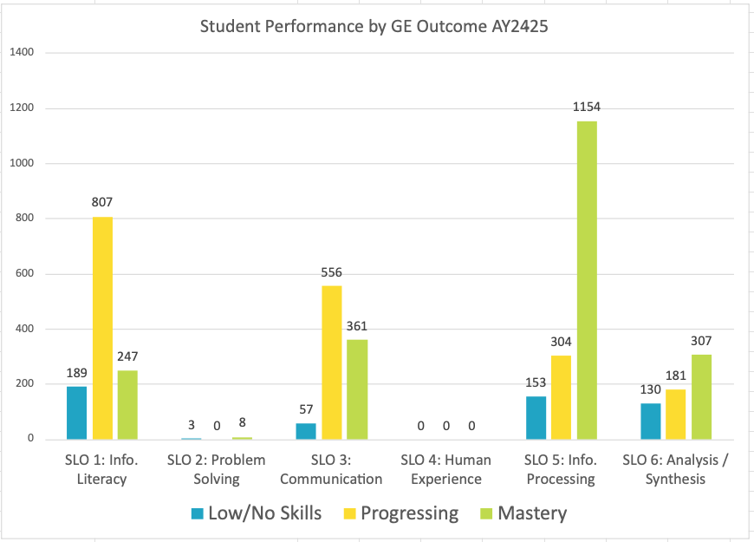

Chart 2: General Education Assessment – By Outcome AY23-24
Chart two indicates that student performance in AY23-24 was strongest in Analysis/Synthesis and Human Experience, where most students exhibited mastery-level skills. Information Processing showed more inconsistent results, with many students at the low-skill and progressing skill levels. Communication and Problem-Solving reflected smaller, developing samples, with Progressing being the majority category for each. No students were assessed in Information Literacy, highlighting a gap in outcome measurement that limits year-to-year comparison.

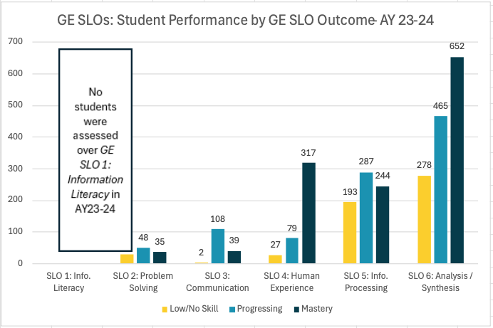
Year-to-Year Summary:
A year-to-year comparison reveals a notable shift in student performance across General Education outcomes. In AY23-24, mastery was concentrated in Analysis/Synthesis and Human Experience, while AY24-25 saw notable improvements in Information Processing and Communication. Information Literacy reemerged in AY24-25 after being unassessed the previous year, whereas Problem Solving and Human Experience continued to have limited or uneven data. Overall, the results suggest improving consistency in outcome coverage and increasing mastery in cognitive and communication skills.

Chart 3: General Education Outcomes – Number of Students by SLO AY24-25
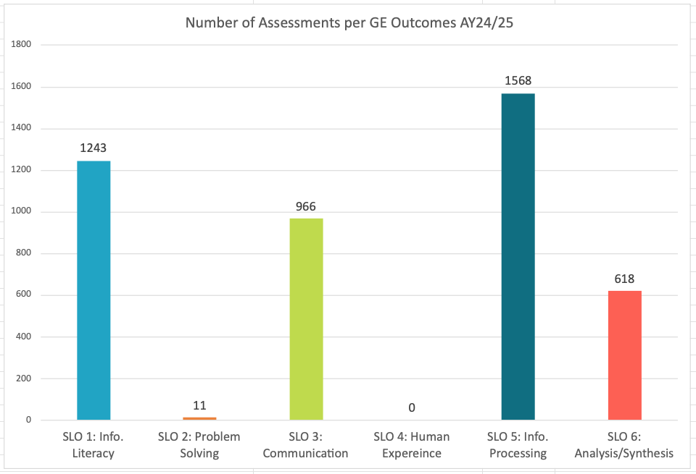

Chart 4: General Education Outcomes – Number of Students by SLO AY23-24
Year-to-Year Summary:
Year-to-year comparisons show significant shifts in assessment coverage across General Education outcomes. In AY23-24, assessment activity focused mainly on Analysis/Synthesis and Information Processing, with limited representation for Communication and Problem Solving, and no assessments for Information Literacy. In AY24-25, overall assessment volume increased, especially in Information Processing and with the reintroduction of Information Literacy, both exceeding 1,200 assessments. There was a notable increase in Communication, while Analysis/Synthesis declined, and Human Experience was not assessed. These changes reflect growing institutional engagement with GE assessment, although the distribution across outcomes remains uneven.

Chart 5: Totals by Bloom’s Level
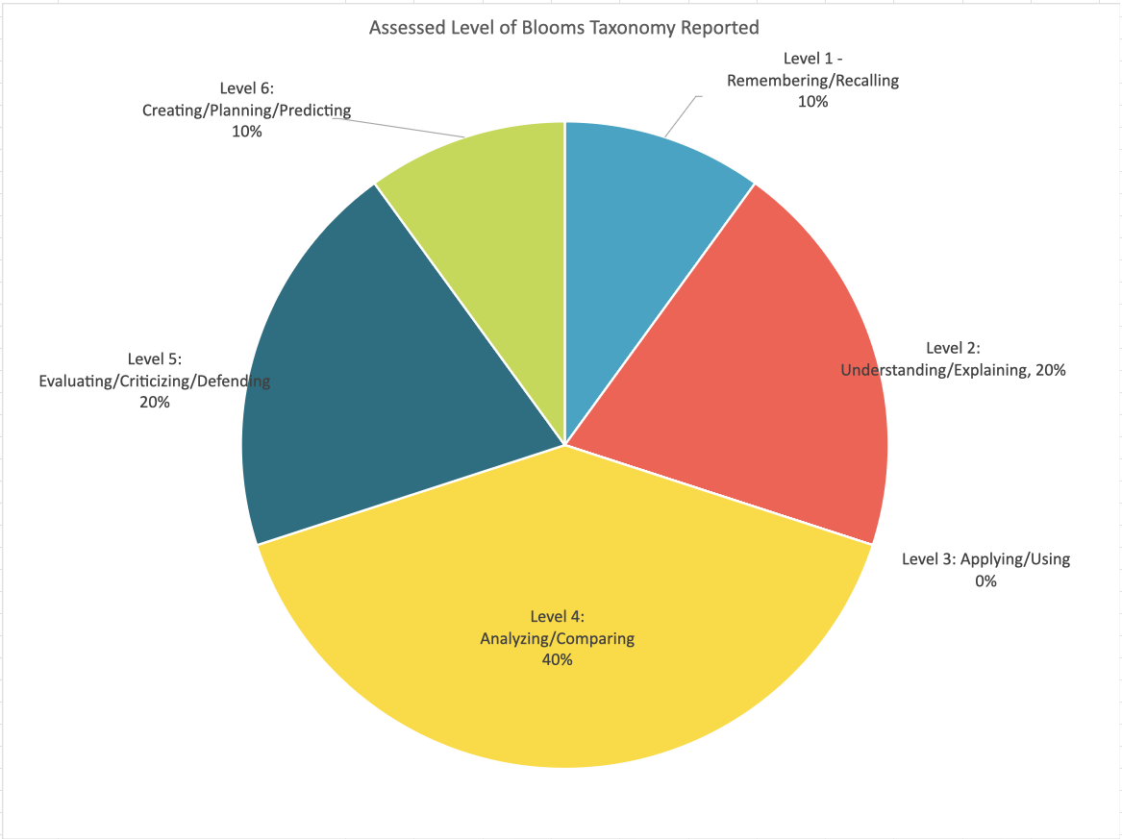
Chart 5 shows that most assessed outcomes focus on higher-order cognitive skills, with 40% of assessments targeting Analyzing and Comparing (Level 4) and 20% each on Understanding/Explaining (Level 2) and Evaluating/Critiquing/Defending (Level 5). The presence of 10% at both the Remembering/Recalling (Level 1) and Creating/Planning/Predicting (Level 6) levels indicates some diversity in cognitive demand. However, no assessments were reported at the Applying/Using (Level 3) level. Overall, assessment activity favors analytical and evaluative tasks, highlighting a strong emphasis on higher-order thinking but suggesting a need to diversify across all levels of Bloom’s taxonomy. This is the first year such data were collected, but was not collected on all submissions.

Career and Technical Education & Non-General Education Reporting – Institutional Learning Outcomes (ILOs)

Institutional Learning Outcomes (ILOs) are assessed through Career and Technical Education programs, as well as coursework in transfer departments that are not aligned with the general education requirements. Faculty use an eclectic set of teaching practices to develop talent and assessments to measure performance. The five ILOs are:

- Quantitative Literacy: Use quantitative skills to analyze and process information.
- Critical Thinking: Acquire, interpret, and analyze information and apply appropriate problem-solving techniques to determine and evaluate solutions.
- Communication: Communicate effectively with clarity and purpose.
- Social Responsibility: Be prepared to practice community engagement that reflects democratic citizenship, environmental responsibility, diversity, and international awareness.
- Personal Responsibility: Be independent lifelong learners who have the skills necessary for economic, physical, social, mental, and emotional wellness.

Summative Data Tables for Non-General Education ILOs
Chart six indicates that Critical Thinking (ILO 2) was the most frequently assessed and highest-performing outcome for AY24-25, with most students demonstrating mastery and many demonstrating proficiency. Quantitative Literacy (ILO 1) and Social Responsibility (ILO 4) showed moderate results with smaller assessment volumes, while Communication (ILO 3) and Personal Responsibility (ILO 5) had limited but high-performing data. Overall, results highlight institutional strength in Critical Thinking, but uneven assessment coverage across the full range of Institutional Learning Outcomes.

Chart 6: ILO - Assessment Results by Outcome AY24-25
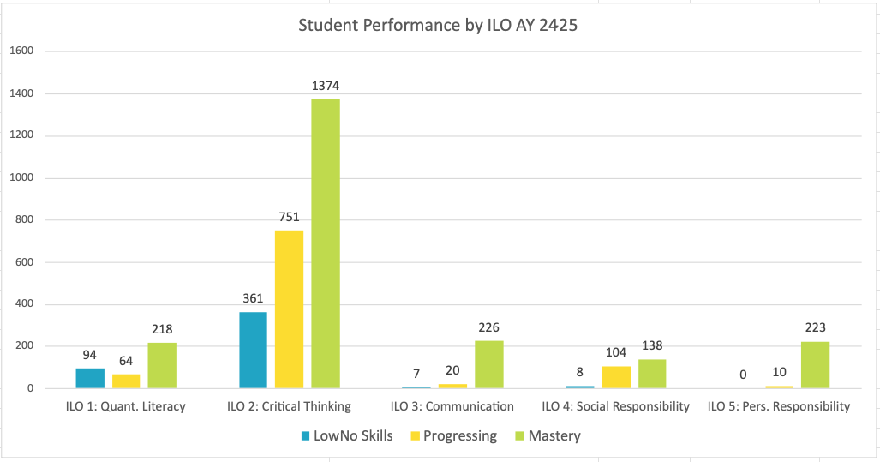

Chart 7: ILO - Assessment Results by Outcome AY23-24
Chart seven indicates that Critical Thinking (ILO 2) was the most frequently assessed and highest-performing outcome in AY23-24, with most students demonstrating progressing or mastery-level skills. Quantitative Literacy (ILO 1) showed moderate performance, while Communication (ILO 3) and Social Responsibility (ILO 4) had smaller assessment volumes but strong mastery results. Overall, the results highlight institutional strength in critical thinking and communication, though assessment coverage across other outcomes remains uneven.

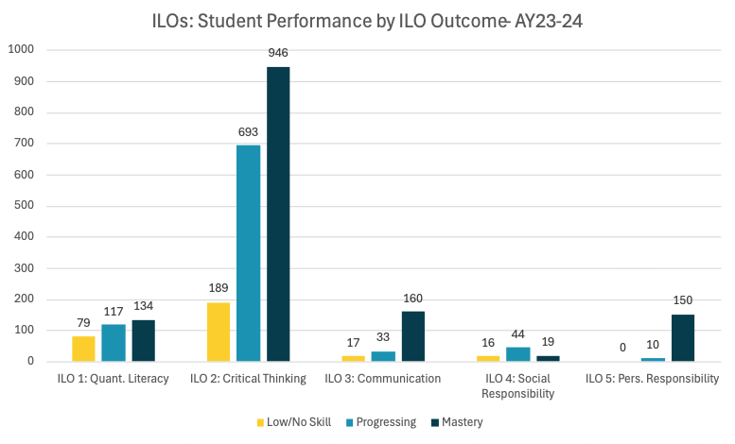
Year-to-Year Summary:
Year-to-year results show consistent institutional strength in Critical Thinking (ILO 2), which remained both the most frequently assessed and highest-performing outcome in AY23-24 and AY24-25. Performance in Quantitative Literacy (ILO 1) and Social Responsibility (ILO 4) was moderate across both years, although assessment volumes increased slightly in AY24-25. Communication (ILO 3) and Personal Responsibility (ILO 5) continued to produce limited but high-performing data, indicating targeted rather than widespread assessment activity. Overall, the results suggest stability in student learning outcomes but ongoing inconsistency in the scope of outcome coverage. ￼

Chart 8: ILO - Number of Students Assessed AY24-25
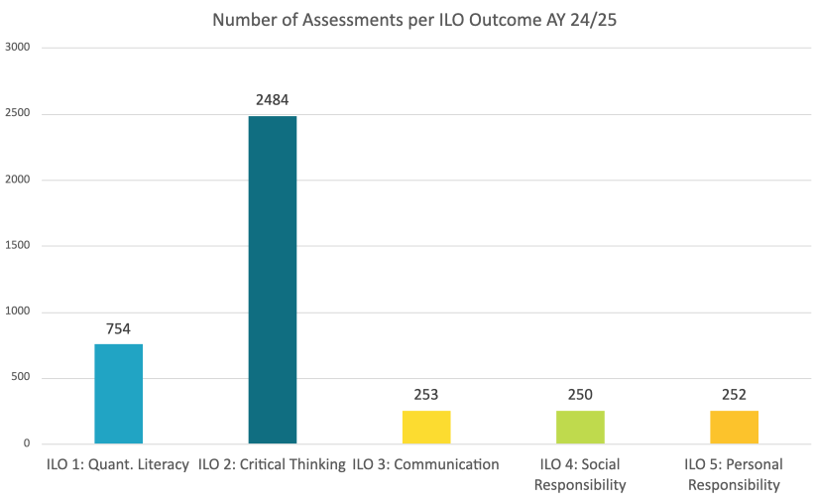

Chart 9: ILO - Number of Students Assessed AY23-24
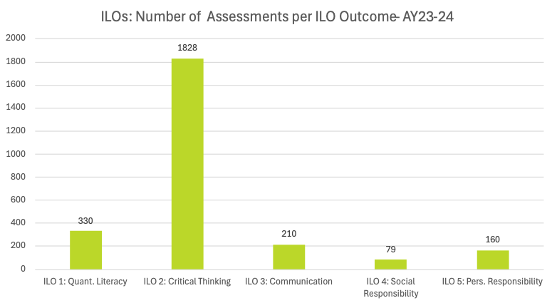
Year-to-Year Summary: Comparisons reveal a significant increase in the number of assessments across nearly all Institutional Learning Outcomes in AY 2024-2025 (3,993) compared to AY 2023-2024 (2,607). Critical Thinking (ILO 2) remained the most frequently assessed outcome, increasing from 1,828 students in AY23-24 to 2,484 in AY24-25, underscoring its vital role in institutional assessment. Quantitative Literacy (ILO 1) also experienced notable growth, with its assessment volume more than doubling. Meanwhile, Communication (ILO 3), Social Responsibility (ILO 4), and Personal Responsibility (ILO 5) each showed modest gains, indicating a gradual expansion of assessment coverage. Overall, AY24-25 demonstrates increased participation and a more balanced assessment across outcomes, though Critical Thinking still leads in institutional assessment activity.

Chart 10: Totals by Bloom’s Level
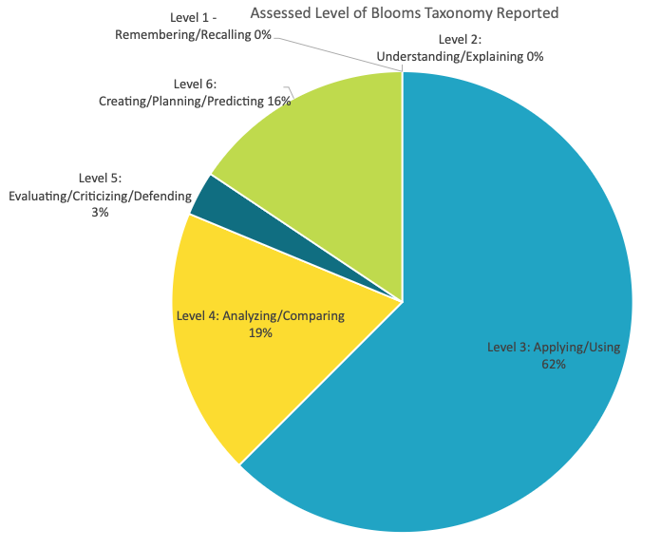
Chart 10 indicates that most assessed outcomes in AY24-25 focus on mid- to high-level cognitive skills, with Applying/Using (Level 3) making up the majority at 62%. Higher order thinking skills are also well represented, with Analyzing/Comparing (Level 4) at 19% and Creating/Planning/Predicting (Level 6) at 16%. In contrast, Evaluating/Criticizing/Defending (Level 5) accounts for only 3%. No assessments were reported at the foundational levels of Remembering (Level 1) or Understanding (Level 2). Overall, the distribution suggests a strong institutional emphasis on applied and integrative learning, with a lesser focus on lower-level cognitive tasks.

Chart 11: Mastery Percentage by Learning Outcome and Year
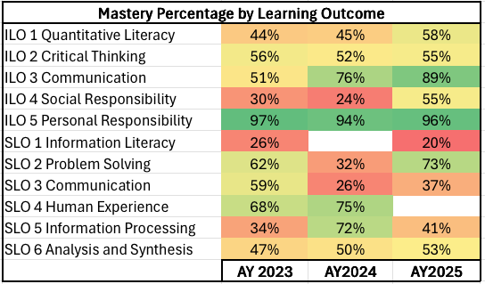
Chart 11 indicates improved mastery across some outcomes from AY 2023 to AY 2025, with the most consistent performance in Personal Responsibility and Critical Thinking. The Communication ILO demonstrated significant gains over time, with mastery increasing sharply to nearly 90% by AY 2025. Quantitative Literacy and Social Responsibility also improved notably, while Problem Solving rebounded strongly after a dip in AY 2024. In contrast, Information Literacy and Information Processing showed inconsistent performance. Overall, the data indicate increasing mastery in key skill areas, especially in higher-order thinking and applied communication, although some learning outcomes still display year-to-year variability.

Chart 12: Progressing Percentage by Learning Outcome and Year
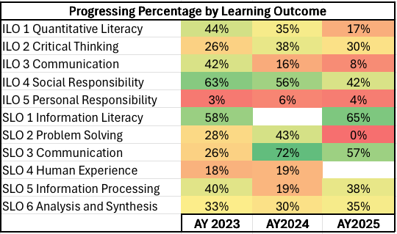
Chart 12 indicates no discernible pattern in progressing scores from AY 2023 to AY 2025. At best, the data suggests a gradual upward trend in student proficiency. Quantitative Literacy, Critical Thinking, and Social Responsibility each show consistent declines in progression rates. SLO Communication outcomes fluctuated, peaking in AY 2024. Information Literacy and Information Processing maintained moderate progressing levels in AYs 2023 and 2025. Personal Responsibility remained low, but this is to be expected with a sustained high level of mastery on this outcome.

Significant Assessment Findings

Through the Program Review cycle, departments report on assessment data and significant findings each year. The examples below reveal some of the curricular decisions programs made based on assessment results. Identifying information has been deleted from the narratives.

Example One:
The data we collect for this assessment frequently shows a reverse bell pattern. We have many students who are able to demonstrate a strong understanding of working with HTML and CSS to build responsive navigation. There are a few students who might understand pieces of HTML and CSS, but we are unable to work with the media queries, but usually students who understand the underlying fundamentals end up being able to do well within this assessment. The students who have low or no mastery have a tendency to not only do poorly with media queries, but they struggle with HTML and CSS as well. Over the years we have looked at the data to think about ways that we could try to scaffold this experience better. One thing we tried recently with our data was to remove students from the data that were getting automatic failures on the assessment by not turning in the project. Even with the removal of those students the ones who tend to miss this assessment are the ones that fall behind in the course work and stop turning in work.
In the department we have discussed why we think students do poorly in the class overall and one of the main contributors we feel is students coming into the class with poor prior knowledge of computer basics. These students are not understanding the basics of file management or working with documents so when they are asked to code they often get overwhelmed in everything that is being asked. We have considered tailoring the curriculum to provide more time for covering file management, but there is not enough time in this course to do so. We have also discussed potentially having students test into the program or take a basic computer elective. We are concerned that by doing that the majority of the students in the program would needlessly be pushed further back in their graduation timeline.
Another solution we have come up with is to take one of the other fundamental courses, which covers professional skills, and to add necessary file management basics to that curriculum. If possible we would like to track how the success/completion of this course with those changes impacts student success.
Example Two:
We administered a pilot, summative assessment for all relevant courses taught by full-time faculty during the last two weeks of the Fall 2024 semester. A total of 19 sections with 365 enrolled students were asked to complete the instrument, and results were reported by instructors via an anonymous survey. A total of 314 students completed the assessment. We are satisfied with the 86% response rate, however; would like to see this number increase to 90% or higher on the next data collection.
Overall, the vast majority (82.2%) of our students attained a mastery level on this instrument by answering 7/8 or 8/8 questions correctly. This high rate of mastery is logical because the instrument questions were written at a Level 1: Remembering/Recalling on Bloom’s Taxonomy and should be the easiest for our students to obtain. However, mastery levels by modality showed some slight differences. The face-to-face modality courses had the lowest level at 75.7%; followed by Online Hybrid/Hybrid modalities at 82.5%; and ending with the online modality at 93.7%. There are several reasons this could have occurred including the nature of student enrolled in these different modalities, pedagogical differences, variations with how the instrument was administered, and number of students assessed. This is an area we would like to look at more closely in a future analysis.
Analysis of results on individual questions showed the lowest success rate on Question 1, which assessed Objective 1: Identify the fundamental elements of the communication process. We think this question had the lowest success rate for two possible reasons. First, we need to look more closely at the question to ensure there was no confusion regarding its construction. Second, there seems to be a trend that students were more and more successful with each question as they progressed. Question 1 may have had the lowest success rate because of the time that lapsed between the concept being learned at the beginning of the semester to the time in which the instrument was administered.
Overall, we are pleased with the results of this pilot summative assessment and think our students performed well to the standard we set. Moving forward due to adopting an Open Educational Resource (OER) for this course in Spring 2025, we will adjust the language of the instrument to match this current text. We plan to administer the slightly modified new instrument in the Fall 2025 semester to all sections regardless of instructor type. We are waiting until the Fall 2025 semester to give all our instructors time to adjust to this new text to ensure we are collecting accurate data. If the Fall 2025 results are similar to these results, we will consider constructing a new, more rigorous instrument assessing students at Level 2: Understanding/Explaining.

Summary and Recommendations
The 2025 reporting cycle reflects substantial growth in institutional engagement with assessment. Overall submission rates reached 54 percent, a 20 percent increase from the prior year, indicating a positive trend toward broader faculty participation and more substantial alignment with institutional learning priorities.
The data reveal an institution maturing in its assessment practices… moving from compliance toward meaningful reflection and improvement. The 2025 results show improvement in participation, coverage, and clarity, but also point to the continued need for coherence, methodological consistency, and integration of assessment results into planning and resource allocation.
Consequently, the Assessment Committee and AEIO Office make the following recommendations:
Standardize Assessment Practices
Institute a common framework for submitting SLO and ILO data. Using a standard intake process, like the JCCC Assessment Data Submission Form or Canvas, would provide the controls necessary to standardize analysis.

Expand Assessment Coverage Across Outcomes
Prioritize increasing participation in underrepresented outcomes like Problem Solving and Human Experience within General Education, ensuring a more balanced distribution of evidence across all outcomes.

Enhance Faculty Development and Feedback Loops
Provide structured professional development on interpreting and using assessment data, emphasizing diagnostic approaches and actionable loop-closing reflections. Consider exemplar or peer-review models to enhance the quality of submissions.

Diversify Cognitive Assessment Levels
Encourage faculty to create assessments that cover the entire spectrum of Bloom’s taxonomy, balancing basic understanding with analytical and creative tasks to capture a broader view of student learning.

Monitor Longitudinal Trends and Institutional Learning Growth
Explore opportunities for longitudinal tracking to better understand patterns of student development over time, beyond annual cohort comparisons.

Limitations
Several key limitations constrain the analysis and commentary in this report, except for the Significant Assessment Findings section, which presents firsthand reflection from faculty. First, individual students were not tracked over time, so the year-to-year differences observed are not indicative of student growth. The data reflect different cohorts rather than changes in development over time. Second, variations in methodology across departments create inconsistencies. Each area may differ in how it aligns assignments with learning outcomes, uses Bloom’s taxonomy levels, and interprets disciplinary expectations. These differences limit comparisons and generalizations of the aggregated results. Third, no institution-wide standard or control ensures that data reported as measuring an Institutional or General Education Learning Outcome actually or consistently achieves this end. Faculty may submit data of varying quality or relevance, which is then combined with other like data without review. Lastly, all data are pooled across course levels, disciplines, and quality thresholds, producing institutional summaries that conceal underlying insights. Overall, this report should be viewed as relaying broad indicators of participation, performance, and general alignment rather than definitive measures of student mastery or learning progress.

Assessment Committee
The Office of Assessment, Evaluation, and Institutional Outcomes could not perform its varied tasks without the support of multiple committee members across the campus. Below is the Academic Year 2024-25 Assessment Committee members.

Assessment Committee Members
Amanda Glass: Co-Chair, Associate Professor of Chemistry
Andrea Thimesch: Assistant Professor/Librarian
Brian Zirkle: Professor of Sociology
Mark Browning: Professor of English
Donna Helgeson: Professor of Mathematics
Yosei Sugawara: Associate Professor of Foreign Language
Jack Ireland: Professor of Automotive Tech
Hondo Tamez: Associate Professor of Information Technology
Charles Foat: Director of Emergency Medical Science

